ADVANCED MATERIALS DEVELOPMENT FROM AGRICULTURAL WASTE FOR ECONOMIC SUSTAINABILITY

Adigun, B.O, Jegede F.I, Sanya O.T
Department of Glass and Ceramic Technology, Federal Polytechnic, Ado-Ekiti, Nigeria.
Corresponding email: bidemiadigun91@yahoo.com

ABSTRACT
With the advancement in technology, the importance of advanced materials like glass ceramics cannot be over emphasized. The production of glass ceramics depends on the importation of some raw materials. The use of agricultural waste like corn cob in the development of glass ceramics will help reduce the volume of solid waste generated and reduce the amount of raw materials imported into the country thereby applying the waste-to-wealth initiative and increase productivity in Nigeria. The objective of this paper is to provide a suitable scientific and economic method of reusing corn cob to develop glass ceramics for useful products. Corn cobs were procured from the Faculty of Agricultural Science, Ahmadu Bello University, Zaria and converted to ash. Chemical analysis to ascertain the chemical constituents of the ash was done by X-ray fluorescence (XRF) which indicated that corn cob ash (CCA) has high silica content (68.70%). A sodium aluminosilicate glass batch was formulated using the corn cob ash and adding alumina and soda ash as supplementary sources of sodium oxide and alumina. The batch formulated for test-melting was 127.56 grams total weight. The petrurgic method was employed for this study. The batch was melted in ceramic moulds at 1200°C and cooled to room temperature at the rates of 1°C, 5°C and 10°C per minute in a temperature-controlled furnace. The resultant glass ceramics were characterized by X-ray diffraction and Scanning electron microscope to determine their molecular structure and their microstructural morphology respectively which indicated the presence of both crystalline and amorphous phases which identified the material obtained from test-melting the batch as glass ceramics.

Keywords: advanced materials, glass ceramics, corn cob, waste, economic sustainability.

1. INTRODUCTION
The conversion of corn cob ash into a stable glass through vitrification is an attractive technology for waste treatment, because it can achieve large waste volume reductions and create a durable waste form. A judicious choice of raw mix along with appropriate heat treatment one can produce various crystalline phases thereby forming glass ceramics. Glass ceramics are fine-grained polycrystalline materials formed when glasses of suitable compositions are heat treated and thus undergo controlled crystallisation to the lower energy, crystalline state (Holland and Beall, 2002). A wide range of glass ceramics with tailored properties have been developed and several comprehensive review articles and dedicated books on their production, properties and applications, have been published (Edgar, 2010).

Glass ceramics have, in principle, several advantages; they can be mass-produced by any glass forming technique, it is possible to design their nanostructure or microstructure for a given application, they have zero or very low porosity, it is possible for them to combine a variety of desired properties (Francis et al., 2002). One example of the fourth advantage is combining very low thermal expansion coefficient with transparency in the visible wavelength range for cooking ware. Another is combining very high strength and toughness with translucency, biocompatibility, chemical durability and relatively low hardness for dental applications (Harnisch and Hulsenberg, 2000).

There had been various research efforts also on the use of corn cob ash (CCA) and other pozzolan as a replacement for cement in concrete. Olutoge et al. (2010) presented a comparative study on CCA, fly ash and ground granulated blast furnace slag (GGBS) high performance concrete. Adesanya and Raheem (2010) studied the workability and compressive strength characteristics of Corn cob ash (CCA) blended cement concrete. Adesanya and Raheem (2009) also assessed the development of Corn cob ash (CCA) Blended Cement. In recent years glass ceramics has been produced by synthesis of materials from ash gotten from agricultural waste such as rice husk, corn cob etc., combination of metal and non-metals had been investigated by sol-gel to produce ceramics (Samuel, 2015).

However, most of the corn cobs generated worldwide is still discarded as waste (Zhang et al., 2010). Also nowadays, natural resources are depleting worldwide, while at the same time the generated wastes from the industries are increasing substantially. In Nigeria, there is a great demand for raw materials in various manufacturing industries (Ramesh et al., 2014). The objectives of this paper are to derive ash from corn cob, carry out chemical analysis on the samples of the corn cob ash to ascertain that it’s suitable for glass ceramics production, formulate a glass batch for the base glass, test-melt the batch and characterize the resultant glass ceramics.

2. METHODOLOGY
Corn cobs were collected from Faculty of Agricultural Science, Ahmadu Bello University, Zaria and air-dried for a week, before being ground to smaller particles sizes of about 10mm (visual observation). According to Adesanya and Raheem (2009), grinding corn cobs to about 10 mm before burning them to ash enhances adequate combustion and reduces the carbon content. The ground corn cobs were placed in an incinerator for combustion into ash at the Department of Building, Ahmadu Bello University, Zaria. The ash obtained was placed in crucibles and placed in a muffle furnace and heated at a temperature of 600°C for 6 hours to reduce the carbonaceous matter and increase the percentage of active silica content, this was carried out at the Department of Metallurgical and Materials Engineering, Ahmadu Bello University, Zaria. The ash was sieved through a 0.25mm sieve with mesh number 60.

2.1. Chemical Analysis
The determination of the chemical composition of the corn cob ash was carried out by X-ray fluorescence spectrometry which identified each of the oxides contained in the ash.

2.2. Batch Formulation
The standard composition of sodium aluminosilicate glass was utilized for the batch formulation of the base glass which was converted to glass ceramics. The corn cob ash was used as the major glass former while alumina and soda ash was used to provide other supplementary oxides required in the batch. The approximation method was used in calculating the batch based on the percentage yield of the major oxides introduced by the various raw materials. A total of 127.56g of batch raw materials was needed for 100g of glass.

2.3. Glass Ceramics Production by Petrurgic Method
The petrurgic method was employed for the development of glass ceramics. The formulated batch was melted in ceramic moulds at 1200°C for 5 hours and cooled to room temperature at the rates of 1°C, 5°C and 10°C per minute in a temperature controlled electric muffle furnace. The glass ceramics production was carried out at Dana Steel Limited, Katsina.

2.4. Microstructural Morphology and Atomic/Molecular Structure Determination
According to ASTM E-986, scanning electron microscopy (SEM) which involves the microstructural morphology of selected spots on each glass ceramic sample was analysed. X-ray diffraction (XRD) according to ASTM E-975 was carried out on glass ceramic sample where the sample was finely ground and homogenized and mounted on a goniometer and gradually rotated while being bombarded with X-rays, producing a diffraction pattern of regularly spaced spots known as reflections which determined its atomic and molecular structure.

3. RESULTS AND DISCUSSIONS
A dark-greyish ash was obtained from the combustion of corn cobs. The ash was heat-treated in a muffle furnace at 600ºC for 6 hours to reduce the carbonaceous matter and increase the percentage of active silica content. The ash was sieved through a 0.2mm sieve which resulted in fine particles to facilitate the melting of the ash at 1200ºC. The result of XRF analysis of the CCA as shown in Table 1 reveals that it contains 68.70% SiO₂ and the rest 29.416%, making the corn cob ash a good source of SiO₂ for glass and glass ceramic production. Also, the Fe₂O₃ content of 3.44% is high enough to serve as a nucleating agent for glass ceramic production (Edgar, 2010).
Table 1 Result of XRF of CCA
Oxides | SiO₂ | P₂O₅ | K₂O | CaO | Na₂O | MgO | TiO₂ | MnO | Fe₂O₃ | SO₃ | BaO
Composition (%) | 68.70 | 1.61 | 4.56 | 9.50 | 4.60 | 5.20 | 0.26 | 0.14 | 3.44 | 0.08 | 0.03

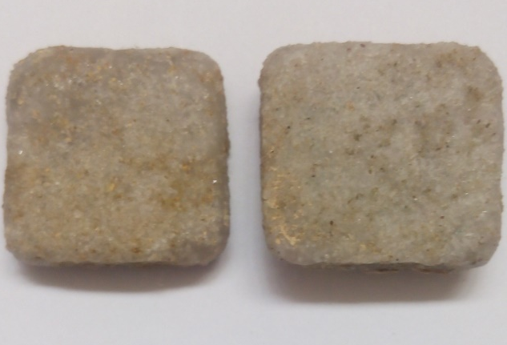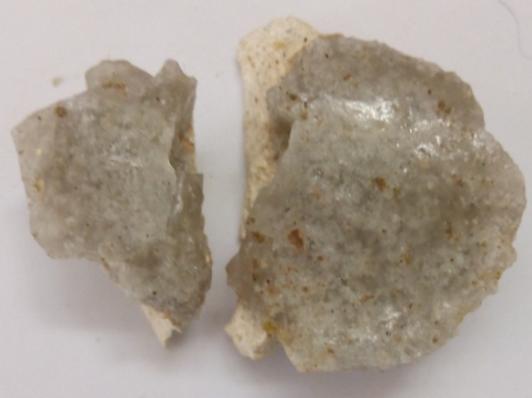
Plate 1a: Glass Ceramics obtained Plate 1b: Glass Ceramics obtained
from cooling at 1ºC/minute from cooling at 5ºC/minute

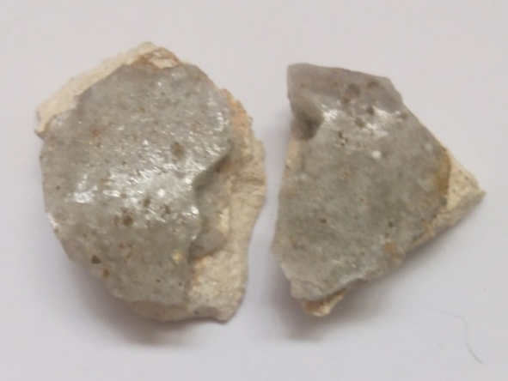
Plate 1c: Glass Ceramics obtained from cooling at 10ºC/minute

Plates 1a, 1b and 1c showed the resultant glass ceramics cooled at varying temperature ranges from molten state. They were characterized by a rough surface which is as a result of inhomogeneity of the melt which is due to the fact that the alumina contained in the batch requires a higher temperature of 1500ºC to melt. Therefore complete melting of alumina failed to occur at 1200ºC. The batch melted at 1200ºC due to the particle size of the batch which was 0.25mm. Also the sodium oxide (Na₂O) contained in the corn cob ash and the addition of Soda ash to supplement for the required amount of Na₂O required for the development of sodium aluminosilicate glass facilitated the melting process by bringing down the melting point of the batch. (The only available furnace at the time of the experiment was an electric furnace with a maximum temperature of 1200ºC)

The following showed the results of SEM and XRD carried out on two of the three different samples of the resultant glass ceramics with the most optimal properties as the two of these samples are of utmost consideration.

Plates 2a and 2b showed the morphology of glass ceramics obtained from cooling at 1ºC/min and 5ºC/min respectively. The morphology of the glass ceramic sample obtained from cooling at 1ºC/min showed an irregularly-shaped structure which was due to the precipitation of ceramics in the glassy matrix. So, the grains and clusters shown by this surface are attributed to the formation of nepheline phases. The morphology of the crystalline phase from glass ceramics obtained from cooling at 5ºC/min was characterized by a rough texture also with irregular shapes on it.

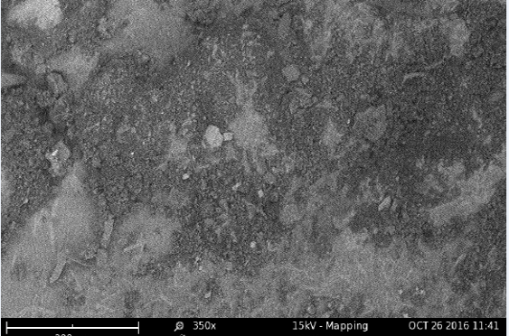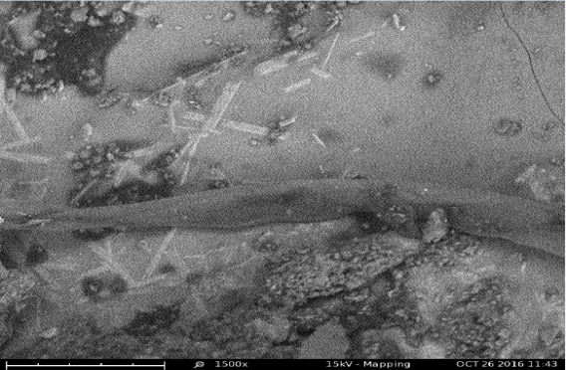
Plate 2a: SEM of Glass ceramics obtained from Plate 2b: SEM of Glass ceramics obtained
cooling at 1ºC/min. Magnified at 350× from cooling at 5ºC/min. Magnified at 6500×

Figures 1a and 1b showed XRD patterns of glass ceramic samples obtained from cooling at 1ºC/min and 5ºC/min respectively. Both indicated sharp Bragg’s peak zones near 2$θ$=27⁰C which signified that nepheline (NaAlSiO₄) was the major crystalline phase present.
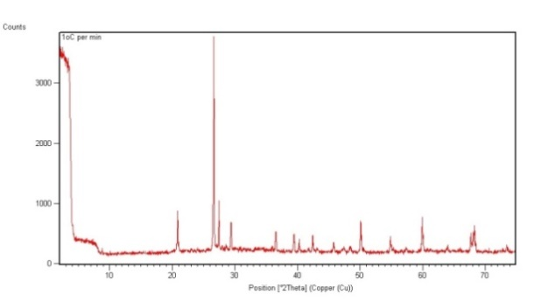
Figure 1a: XRD Pattern of glass ceramic cooled at 1ºC/min
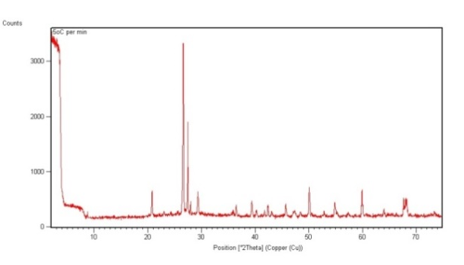
Figure 1b: XRD Pattern of glass ceramics cooled at 5ºC/min

4. CONCLUSION
From the results and discussions of this study, the following conclusions were drawn;

- By analyzing the CCA it was found that it contained compounds such as 68.70% SiO₂ and the rest 29.42% which can be used for glass and glass ceramics production.

- The fine particle size of the batch which is 0.25mm and the addition of soda ash as a supplementary raw material for Na₂O served as a flux which made it possible for the batch to melt at 1200ºC for 5 hours.

- The alumina powder which was added as a supplementary source of Al₂O₃ was difficult to melt and homogenize with the other raw materials thereby resulting in improper fining.

- The presence of crystalline phases of the samples confirmed by XRD and the morphology shown by SEM confirmed both crystalline and amorphous phases as seen in the microscopy which identified the material obtained from test-melting the batch as that of glass ceramics.

- The glass ceramic products contained Nepheline (NaAlSiO₄) crystalline phase dispersed in amorphous glass matrix from the result of their characterization by XRD and SEM.

- The glass ceramic samples developed are suitable for commercial applications like, floor tiles and wall claddings, building bricks, table ware, structural prostheses etc.
The production of glass ceramic materials is a field of material technology that requires special manufacturing processes suited to their end use requirements.

REFERENCES
Adesanya, D. A. and Raheem A. A. (2010). A study of the permeability and acid attack of corn cob ash blended cements. Construction and Building Materials. Vol. 24, pp.403.

ASTM E986-04 (2010). Standard Practice for Scanning Electron Microscope of Glass and Glass Ceramic Materials. ASTM International, West Conshohocken, PA. Retrieved May 26, 2016, from http://www.astm.org.
ASTM E975-13 (2015). Standard Practice for X-ray Crystallography of Glass and Glass Ceramic Materials. ASTM International, West Conshohocken, PA. Retrieved May 26, 2016, from http://www.astm.org.

Edgar D.Z. (2010). A bright future for glass ceramics. The American Ceramic Society Bulletin. Vol. 89, pp. 46-52.

Francis, A. A., Rawlings, R. D. and Boccaccini, A. R. (2002). Glass ceramics from mixtures of coal ash and soda lime glass by the petrurgic method. Journal of Material Science. Vol. 21, pp. 975-978.

Harnisch, A. and Hulsenberg, D. (2000). Mechanical properties of microstructurable glasses. Glass Science Technology. pp. 67-72.

Holland, W. and Beall, G. (2002).Glass-Ceramic Technology. The American Ceramic Society, Westerville, OH. pp. 231-236

Oladeji, J.T. (2010). Fuel characterization of briquettes produced from corncob and rice husk residues. Pacific Journal of Science and Technology, Vol.11 (1), pp. 101-106.

Olutoge F.A., Bhashya V., Bharatkumar B.H., Sundar and Kumar S. (2010). Comparative studies on CCA, fly ash and GGBS high performance concrete. Proceedings of National Conference on Recent Trend and Advancement in Civil Engineering-TRACE2010.

Ramesh M., Karthic K.S. and Kumaravel A. (2014). Construction materials from industrial wastes – A Review of Current Practices. International Journal of Environmental Research and Development. Vol. 4, pp. 317-324.

Samuel A.G. (2015). Sol-gel Synthesis of Rice Husk Ash for the Production of Glass Ceramic. (Unpublished master’s thesis). Ahmadu Bello University, Zaria. pp. 28

Zhang, M., Wang, F., Su, R., Qi, W., and He, Z. (2010). Ethanol production from high dry matter corncob using fed-batch simultaneous saccharification and fermentation after combined pre-treatment. Bio-resource Technology. Vol. 101, pp. 4959-4964.

