ANTIBACTERIAL AND ANTIFUNGAL ACTIVITIES OF SYNTHESIZED Mn (II) AND Fe (III) MIXED LIGAND COMPLEXES OF ISATIN- ISONICOTINYLHYDRAZONE WITH ANILINE

¹GRACE E. INIAMA, ²EDEDET A. ENO, ³ISAAC T. IORKPILIGH
^{1&2} Department of Pure and Industrial Chemistry, University of Calabar-Nigeria
³Department of Chemistry, Benue State University, Markudi-Nigeria

ABSTRACT
The ligand, isatin-isonicotinylhydrazone (ISIS) was synthesized at room temperature by the condensation reaction of isonicotinylhydrazide and isatin. This synthesized ligand was interacted with Mn (II) salt and aniline and Fe (III) salt and aniline to obtain the two novel mixed ligand complexes. The synthesized compounds were characterized using some physicochemical properties such as melting point, solubility, conductivity and spectral analysis like infrared spectra and UV-visible spectra. The melting points of the ligand and the complexes were high (288-342ºC) while the conductivities were low. From the elemental analysis, a 2:1:2 primary ligands to metal to secondary ligand molar ratio were established. The infrared spectral data revealed the bidentate coordination mode of the primary ligand from which bonding occurred through the nitrogen of the azomethine and oxygen of the carbonyl functional groups. The octahedral geometries for the complexes were elucidated from the electronic absorption spectral data obtained. Information derived from the antibacterial and antifungal studies showed that the metal complexes have higher antibacterial activities (17.0-22.0mm) than antifungal activities (9.0-13.0mm). In all, the metal complexes proved to be better antimicrobial agents than the free ligand.

Keywords: Synthesis, Characterization, Schiff base, Complex, antibacterial, antifungal

- Introduction
Schiff bases also called imines are compounds identified by the presence of the azomethine functional group (C=N) [1]. They are formed when aldehydes and ketones react with amines. This reaction is known to precede best at a pH of 4 or 5 as anything below or above these pH values slow down the reaction or prevent its occurrence [2]. Although recent studies have shown that Schiff bases can be synthesized under solvent free conditions using catalysts or by microwave irradiation.[3]. Schiff bases are known to form very stable complexes with the transition metals [4] which possess remarkable biological activities [5]. These complexes are widely applied in food industries, pharmaceuticals, agrochemicals, chemical analysis, catalytic processes and even anticorrosion reactions [6]. They serve as antimicrobial, antitumor, anticancer, anti-inflammatory, analgesics, and cytotoxic agents [7]. This present work is a continuation of a series of syntheses, characterization, and antimicrobial studies of transition metals mixed ligand complexes. This report is on Mn (II) and Fe (III) mixed ligand complexes derived from isatin- isonicotinylhydrazone with aniline.

- Experimentals
All chemicals used for this research were of analytical grade purchased from sigma Aldrich and used without further purification. Shimadzu Perkin Elmer spectrum BX Spectrophotometer, Perkin Elmer Lambda 25 UV-visible spectrophotometer, Perkin Elmer elemental analysizer, Pico Lab India conductivity meter, Gallenkamp melting point apparatus, Uniscope SM 9053 Laboratory oven, nutrient algae, potato dextrose agar, autoclave, aluminum foil paper, Weighing balance, Nose mask, meter rule, cotton wool, hand gloves, petri dishes, wire loop, paper disc.

Synthesis of the Schiff base ligand isatin-isonicotinylhydrazone (ISIS)
Ethanolic solution of isonicotinylhydrazide (0.01mol, 1.37g) in 50ml ethanol was added to ethanolic solution of isatin (0.01mol, 1.52g). Three drops of glacial acetic acid were added. The resulting mixture was stirred magnetically for 3 hours and the solution was left to stand overnight [8]. The light orange precipitate formed was filtered, washed with methanol and dried over anhydrous fused calcium chloride in a desiccator. Equation for the reaction is:
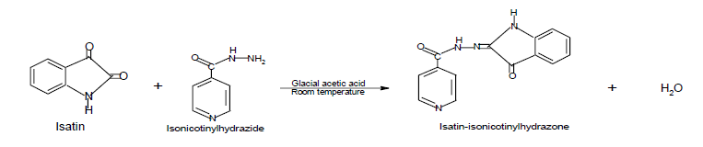

4. Synthesis of the metal (II) complexes
The complexes were synthesized by mixing 2:1:2 molar ratio quantities of the primary ligand with the Mn (II) salt in 50 cm³ ethanol. The mixture was stirred magnetically for 15 minutes after which 20 ml aniline, the secondary was added and stirred for 2 hours. The precipitates formed were filtered, washed several times with ethanol and dried over anhydrous calcium chloride in desiccators. Procedure was repeated with Fe (III) salt [8].

5. Antimicrobial Studies
The antibacterial activity of isatin-isonicotinylhydrazone and its Mn(II) and Fe(III) mixed ligand complexes were examined in vitro by paper disc diffusion method. All materials used were sterilized in a hot air oven and the colony of the tested isolates were sub-cultured and first incubated for about 6-8 hours before putting into agar plates. The bacteria culture media were prepared by adding 28.00g of the nutrient agar to 1000cm-3 of distilled water in a conical flask and heated for about 20minutes to ensure proper dissolution. This was later autoclaved at 120^{oC} for 15 minutes and 20cm3 of this was transferred to each of the already sterilized petri-dishes, covered and kept to set. The microbes, Staphylococcus aureus, Salmonella typhi, Escherichia coli, Aspergillus niger, T. rubrum and Candida albican were inoculated on separate dishes. A hole was bored on the nutrient agar and synthesized compounds introduced. This was allowed to stand for 24 hours. The zones of inhibition were then measured in millimeter [9, 8], Fungi were screened by using potato dextrose agar and almost same procedure was repeated. The minimum inhibitory concentration of the ligand and the complexes were carried out using double serial dilution method containing 20, 10, 5 and 2.5mg/ml of the test compounds. Streptomycin and Fluconazole drugs were used as reference standards [10, 11].

6. Results
Table 1: Physical properties of ISIS and its complexes
Complex/ ligand | Colour | % yield | Melting point (^{O}C) | Conduc-tivity  (µs) | Found (Calcd%)
 |  |  |  |  | C | H | N
ISIS C₁₄H₁₀N₄O₂ | white | 83.41 | 287.6 | 0.03 | 63.2  (63.4) | 3.8  (3.9) | 21.1  (21.2)
Mn(ISIS)₂(A)₂ | Reddish brown | 48.61 | 321.8 | 0.11 | 62.1  (62.3) | 4.4  (4.6) | 18.1  (18.3)
Fe(ISIS)₂(A)₂ | Reddish brown | 34.22 | 292.6 | 1.10 | 62.0  (62.3) | 4.4  (4.4) | 18.0  (18.1)

Table 2: Summary of Spectroscopic Data for ISIS and its complexes (cm⁻¹)
Ligand/ complexes | v  (N-H) | v  (C=O) | v  (C=N) | v  (M-N) | v  (M-O) | Band (cm⁻¹) | Assignment
ISIS | 3229s | 1708s | 1613s | - | - | 34,602  30,674  39,682 | n – σ* n – π* π – π*
Mn(ISIS)₂(A)₂ | 3231s | 1682s | 1619s | 599w | 445w | 28,901  23,148  21,413 | π – π*  ⁶A1g → ⁴T1g  6A1g → 4T2g
Fe(ISIS)₂(A)₂ | 3232s | 1675s | 1617s | 655w | 440w | 41,152  21,881  19,531 | n- π*  π – π*  ⁶A1g → ⁴T2g  6A1g →4T2g

Table 3: Inhibition zones of the ligand and the complexes
Compounds | S. typhi | E. coli | S. aureus | A. niger | T. rubrum | C. abican
ISIS | 17.0 | 16.0 | 15.0 | 9.0 | 11.0 | 11.0
[Mn(ISIS)₂(A)₂] | 18.0 | 21.0 | 22.0 | 9.0 | 12.0 | 11.0
[Fe(ISIS)₂(A)₂] | 17.0 | 19.0 | 20.0 | 12.0 | 13.0 | 12.0
Streptomycin/Fluconazole | 24.0 | 26.0 | 25.0 | 23.0 | 23.0 | 22.0

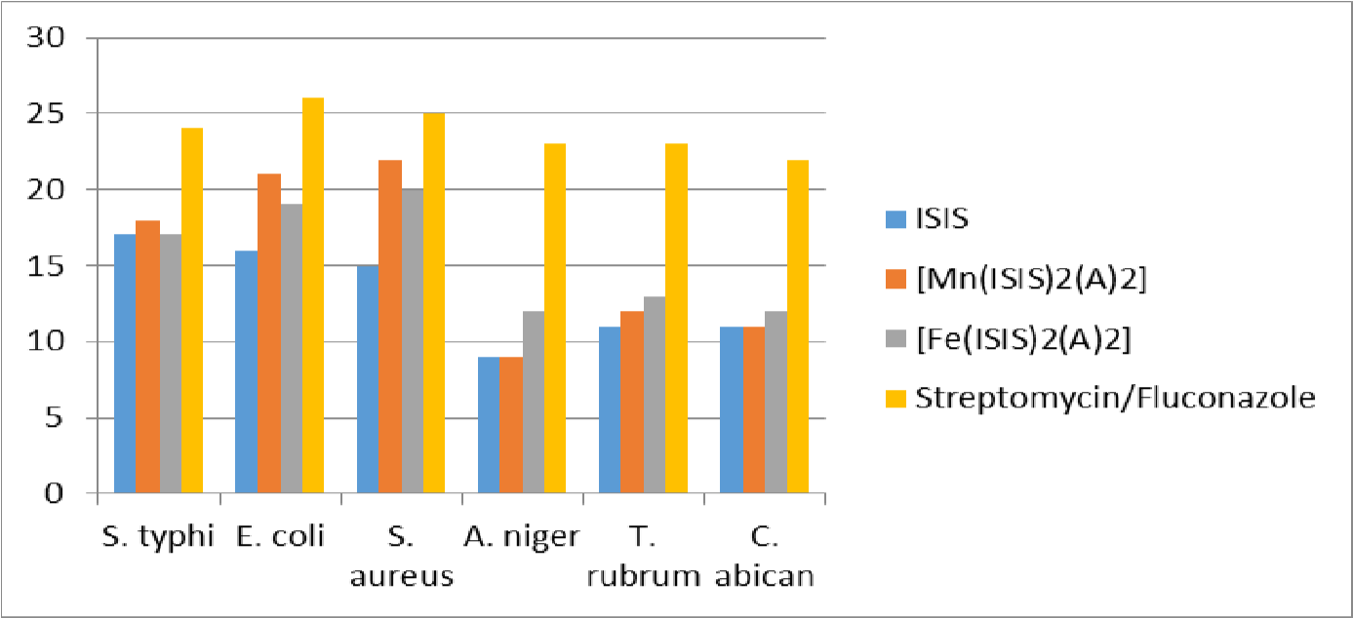

Fig. 1: Antimicrobial properties of the ISIS and its metal complexes

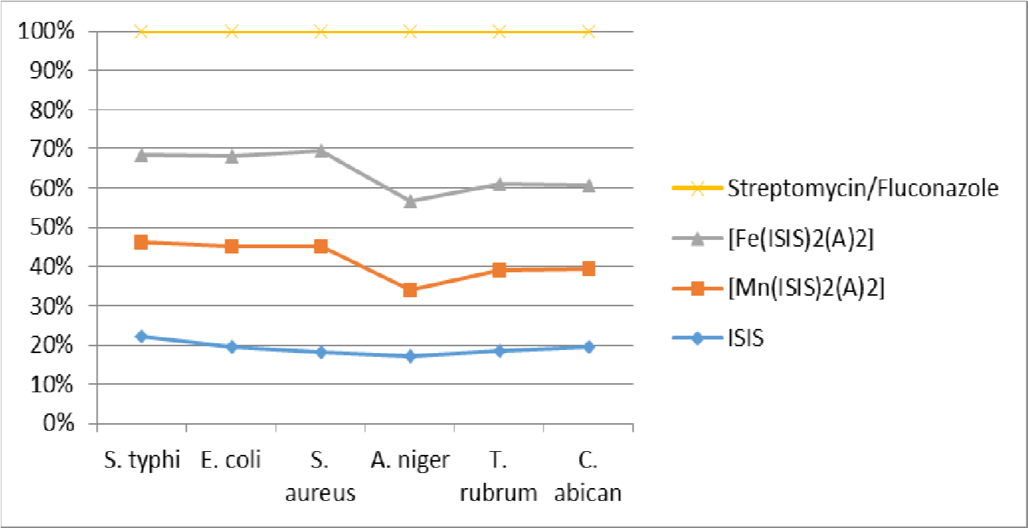

Fig. 2: Distribution plot for the inhibition zones

Table 4: Minimum inhibitory concentrations of ISIS and its mixed ligand complexes (mg/ml )
Compounds | S. typhi | E. coli | S. aureus | A. niger | T. rubrum | C. abican
ISIS | 10.0 | 5.0 | 5.0 | 10.0 | 10.0 | 5.0
[Mn(ISIS)₂(A)₂] | 5.0 | 5.0 | 10.0 | 10.0 | 10.0 | 10.0
[Fe(ISIS)₂(A)₂] | 5.0 | 5.0 | 2.5 | 10.0 | 10.0 | 10.0

Table 5: Minimum bactericidal and minimum fungicidal concentrations of ISIS and its mixed ligand complexes (mg/ml)

Compounds | S. typhi | E. coli | S. aureus | A. niger | T. rubrum | C. abican
ISIS | 10.0 | 5.0 | 10.0 | 10.0 | 10.0 | 10.0
[Mn(ISIS)₂(A)₂] | 10.0 | 10.0 | 10.0 | 10.0 | 10.0 | 10.0
[Fe(ISIS)₂(A)₂] | 5.0 | 5.0 | 2.5 | 10.0 | 10.0 | 10.0

7. Discussion
The physical properties of the synthesized compounds were recorded in Table 1. The properties range from light orange colour for the ligand, reddish brown for Mn(II) and Fe(III) complexes, the powdery nature, the melting point to molar conductance. The melting points of the compounds were high (287.6 - 321.8^{oC}); this seems to suggest the strong bonding network between the ligands and the metal ions thus, their polymeric nature. The conductivities of the ligand and its complexes were low (0.03- 1.10 μs) inferring the non-electrolytic nature [12, 13]. The ligand and complexes were stable as they did not decompose while being stored for over two months period of time in a desiccator. They were only soluble in coordinating solvents like acetone, DMF etc. The elemental analysis obtained correspond to the expected empirical formula; affirmed the metal to ligand molar ratio and the purity of the complexes.

8. Infrared spectra
The infrared vibrational bands of significant functional groups of both ligand and its complexes were presented in Table 2. The spectra of the ligand and the complexes show two bands within the range 3100-3375cm-1 which were assignable to v(NH) stretching vibration. The ligand exhibited bands around 1607cm-1 and 1010cm-1, were attributed to v(C=N) of the imine group and v(N-N) vibrations respectively. In the ligand, the band at 1627 cm-1 was assigned to the azomethine C=N stretching. This band shifted to frequencies of 1619 cm-1 and 1617 cm-1 for the Mn (II) and Fe(III) respectively indicating coordination of the azomethine nitrogen to the metal ions. The lactonyl carbonyl band of the ligand was at 1708 cm-1. The band was found to be lowered to1682 and 1675 cm-1 in the spectra of the Mn(II) and Fe(III) complexes respectively. This also affirmed the coordination of the oxygen atom to the metal ions. The bands at 599 and 655 cm-1were assigned to the M-N vibrations while that between 445 and 440 cm-1were due to M-O bond. All these are in conformity with earlier works of [14, 8, 2,16,17

9. Electronic spectra
The electronic absorption spectra of Mn(II) and Fe(III) complexes tend to resemble each other because both are d5 ions and their absorption bands are a series of relatively very weak bands These bands observed at the range of 19,531 - 41,1152cm-1 and are assignable to 6A1g →4T2g, 6A1g →4T1g, n-π*, & π- π* transitions. The spectral patterns are indicative of octahedral configurations around the Mn(II) and Fe(III) complexes [15,18,19].

10. Antimicrobial analysis
The antimicrobial studies results compared to that of streptomycin and fluconazole are recorded in Tables 3,4 and 5. The results clearly show that the ligand and the mixed ligand complexes are capable of inhibiting bacterial growth even at very low concentrations. The microbial strains used for the study were: Staphylococcus aureus, Salmonella typhi, Escherichia coli, Aspergillus niger, T. rubrum and Candida albican. Fe(III) chelate was prominently active against a broad spectrum of bacteria such as S. aureus, S. typhi, and E. coli, in which at very low concentrations of 2.5- 5.0mg/ml complete elimination occurred. The zones of inhibition caused by the Mn(II) and the Fe(III) chelates were higher (18-22mm) on the bacterial strains than the fungal strains ( 9-13mm). The susceptibility test i.e the bactericidal (MBC) and fungicidal (MFC) minimum concentrations conform with the minimum inhibitory concentrations, MIC and affirmed the effectiveness of the synthesized chelates [5, 9, 12].

Conclusion
The synthesized ligand, isatin-isonicotinylhydrazone (ISIS) acted as a bidentate molecule interacting with the secondary monodentate ligand and the metal ions to form octahedral complexes. These chelates were screened against the named bacteria and fungi. The antimicrobial studies indicated that the complexes show higher activities than the free ligands but in all, the synthesized compounds demonstrated impressive degrees of antimicrobial activities

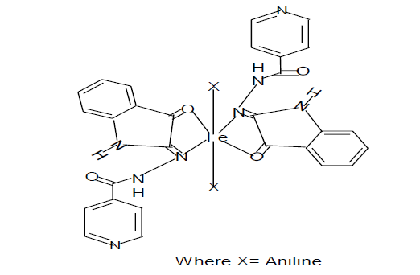
Fig. 2: Proposed structure for the metal complexes

References
- Munde, A. S., Shelke, V. A., Jadhav, S. M., Kirdant, A. S., Vaidya, S. R., Shankarwar, S. G. and Chondhekar, T. K. Synthesis, characterization and antimicrobial activities of some transition metal complexes of biologically active asymmetrical tetradentate ligands. Advances in Applied Science Research, 3(1): 175-182. (2012)
- Iniama, G. E., Iorkpiligh, T. I. & Essien, B. P. Synthesis, characterization, antibacterial and antifungal activities of Co(II), Ni(II) and Cu(II) Schiff base complexes derived from methionine and salicylaldehyde. Chemistry Research Journal, 3(3), 34-39. (2018)
- Patil, S., Jadhav, S. D. and Patil, U. P. Natural acid catalyzed synthesis of Schiff base under solvent-free condition: as a green approach. Archives of Applied Science Research, 4(2): 1074-1078. (2012)
- Sikarwar,P., Tomar,S.,& Singh,A. P., Synthesis, characterization and antimicrobial activity of transition metal(II) complexes of Schiff bases derived from 2-aminophenol and vanillin. International Journal of Recent Trends in Engineering & Research, 221-229. (2016)
- Genin, M. J.,Biles, C., Keiser, B. J.,Poppe, S.M., Swaney,S.M., Tarpley,G.W.,Yagi, Y.,& Romero,D.I.. Novel 1,5-Diphenylpyrazole Non nucleoside HIV-1 Reverse Transcriptase Inhibitors with enhanced Activity versus the Delavirdine- Resistant P236L.Mutant lead Identification and SAR of 3- and 4-substituted Derivatives. J. Med. Chem.,43(5) 1034-1040. (2000)
- Sharma, S. and Fahmi, N. Synthesis, spectroscopic characterization and antimicrobial activity of manganese(II) complexes with unsymmetrical bidentate schiff bases. Asian Journal of Science and Technology, 7(1): 2203-2207. (2016)
- Patil, C. J., Patil, M. C., Patil, N. A. and Kohle, D. Synthesis of aromatic heterocyclic ketimines: part –II. Synthesis, characterization and biological studies of copper complex of biomolecule. Asian Journal of Research in Chemistry. 10(3): 383-387. (2017)
- Iniama, G. E., Nfor, E. N., Okon E. D. and Iorkpiligh, T. I. Antimicrobial activities of synthesized zinc(II) mixed-ligand complexes derived from 2-acetylpyridine-4- phenylsemicarbazone and nitrogen-sulphur monodentate ligands. International Journal of Scientific and Technology Research, 3(11): 73-77. (2014)
- Grover, A., Bhandari, B.S, & Rai, N. Antimicrobial activity of medicinal plants-Azadirachta indica, A Juss, Allium cepa and Aloe vera. International Journal of Pharmaceutical Technology Research.3(2), 1059-1065 (2011)
- Petrus, E. M., Tinakumari, S., Cai, L.C., Ubong, A.,Tunnung, R., Elexson,N., Chai,L.F. & Son, R. A study on the minimum inhibitory concentration and minimumbactericidal concentration of nanocolloidal silver on food-borne pathogens. International Food Research Journal.18 (1),55-66. (2011)
- Yilmaz, M.T. Minimum inhibitory and minimum baeterial concentrations of boron compounds against several bacteria strains. Turkish Journal of Medical Sciences, 42(2), 1423-1429. (2012)
- Ogunniran, K. O., Ajanaku, K.O., James, O.O., Nwinyi, C.O. & Allensela, M.A. Cobalt(II) complexes of mixed antibiotics: synthesis, characterization, antimicrobial potential and their effect on alkaline phosphate activities of selected rat tissues. International Journal of Physical Science, 3(8): 177-182. (2008)
- Didarul, A. C., Uddin C.M. & Hoque F.. Dioxouranium(VI) complexes of some bivalent tridentate Schiff-base ligands containing ONS donor. SetChiang Mai Journal of Science. 37(3): 443-450. (2010)
- Iniama, G. E., Offiong, Nfor, E. N. & Ayi, A. A,. Mixed-ligand complexes of nickel(II) with 2-acetylpyridine thiosemicarbarzone and some N/S monodentate ligands : synthesis, structural characterization and antimicrobial activity. Global Journal Of Pure and Applied Sciences, 14 (4), 411-415 (2008)
- Iniama, G. E., Olanrele, O. S. & Iorkpiligh, I. T.. Synthesis, characterization and antimicrobial studies of Mn(II), Ni(II) and Cu(II) mixed ligand complexes derived from isatinphenylhydazone and nitrogen/sulphur monodentate ligands. International Journal of Science and Research, 4 (9), 2084-2088 (2015)
- Kumar, S. K., Varma, C.P., Reena, V. N.& Aravindakshan, K.K. Synthesis characterization, cytotoxic, anticancer and antimicrobial studies of novel Schiff base ligand derivedfrom vanillin and its transition metal complexes. Journal of Pharmaceutical Science and Research, 5(4),1794-1803 (2017)
- Ndahi, N. P. and Nasiru, Y. P. complexes of cobalt(II), nickel(II) and zinc(II) with Schiff bases derived from 4-anisaldehyde. International Journal of Pharmaceutical Sciences and Research, 3(12): 5116-5120. (2012).
- Mohamed, G. G., Omar, M. M. & Hindy, A. M.. Metal complexes of Schiff bases: preparation, characterization, and biological activity. Turkish Journal of Chemistry, 30(1), 361-382. (2006)

