CURRICULUM VITAE

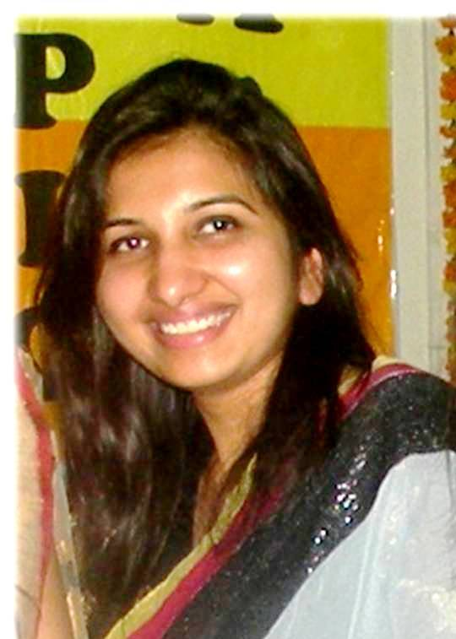

DR. POONAM GOEL

CAREER OBJECTIVE:

To continue my career with an organization that will utilize my MANAGEMENT, SUPERVISION & ADMINISTRATIVE skills to benefit mutual growth and success. 18 months of working in Dental college and hospital has enhanced competencies, including all phases of dentistry and oral pathology. Highly organized, trainable and adjust well to all environments. Possess the ability to create and present an excellent image of the organization and its service to patients. It will be a pleasure to seek a position as Dental Specialist and Oral pathologist to utilize my exceptional skills and knowledge in a renowned dental care organization.

PERSONAL PROFILE

- Name : Dr. Poonam Goel
- Father’s name : Sh. B.K. Goel
- Date of birth : 11.11.1987
- Age : 29 Years
- Residential address : 04 Jai Bharat Enclave Jain Road, Dwarka
Mor, Uttam Nagar, New Delhi-110059
- E-mail address : dr.poonam1187@gmail.com
- Telephone no. : Mob. 09557046426, 09968288309,
Res. 01125352226
- Educational qualification:
Sr. No. | Exam Passed | Name of  Institution/University | Year | % of marks
1 | 10th (Sec. School) | C.B.S.E., New Delhi | 2003 | 89%
2 | 12th (Sr. Sec. School) | C.B.S.E., New Delhi | 2005 | 79%
3 | B.D.S. | M.M.College of Dental Sciences and Research, Mullana, Kurukshetra University, Mullana, Ambala, Haryana | 2010 | 63%  (First Division)
4 | M.D.S (Oral & Maxillofacial Pathlogy) | M.M.C.D.S.R., Maharishi Markandeshwar University, Mullana, Ambala, Haryana | 2015 | 75%  (University Topper)  Examiners-Dr. Ranganathan  Past President,IAOMP  Dr. Jay Gopal Ray  President, IAOMP

- Internship :
Completed internship in Nov. 2011 from M.M.College of Dental Science and Research, Mullana, Ambala (Kurukshetra University)
Registered with Dental council of Delhi, Regn. A-9687
Dated- 05.12.2011
Valid upto 31/12/2019

- Registration No. :

Senior lecturer in Seema Dental College & Hospital, Rishikesh, Uttarakhand, from 15th June, 2015 till 30th November, 2016.

- Previously worked as :

- Experience as Senior Lecturer : 1 year 6 months
Academic Head and Faculty,
Dr. Bhatia’s Medical Institute, Patel Nagar, New Delhi (A Leading Institute of North India for preparation of entrance exams for, MD, MS, MDS MBBS)
- Presently working as :

- Achievements and Training : Enclosed separately

It is assured sir that I will leave no stone unturned to satisfy my seniors/officers with my work and performance if an opportunity to serve in the hospital is given.

Dated- 05-05-2017 (Dr. Poonam Goel)

ACADEMIC ACHIEVEMENTS

Area of Interests
- Oral precancer and cancer
- Salivary gland pathology
- Forensic odontology
- Soft tissue sarcomas

ORGANIZED CONFERENCES
- Organized a CDE program on “Clinico-pathological Correlation of Jaw Swellings” by the Department of Oral and Maxillofacial Pathology, at Seema Dental College, Rishikesh on 16th January, 2016. Presented cases for panel discussion in this CDE programme.
- Organized a CDE program on “Microscopic Insights to Macroscopic Dilemnas” by the Department of Oral and Maxillofacial Pathology, at M.M.College of Dental Sciences & Research, Mullana, Ambala, Haryana on 8th February, 2014. Presented a Slide seminar on rare and diagnostically challenging cases.

ATTENDED CONFERENCES
- Attended a lecture on “Management of Head and neck Cancer” by Dr. Gauri Kiefer, Clinical assistant professor, University of Pittsburgh, USA and a lecture on “Palliative care of Terminally ill patients” by Dr. Brenda, Palliative Care Consultant, United Kingdom on 07th November, 2016.
- Attended CME on “Premalignant conditions of oral cavity” in AIIMS, Rishikesh on 06th November, 2016.
- Attended “International day of older persons” at Seema Dental College & Hospital, Rishikesh on 27th September, 2016. The chief guest of the programme was Shri Harish Chandra Rawat, Honable CM of Uttarakhand.
- Attended “Role of CBCT in today’s Dental Practice” by Dr. Shalini Suri at Seema Dental College & Hospital, Rishikesh on 22nd June, 2016.
- Attended a lecture on “Power your Practice” by Dr. Srihari Vishwakarma, S.B. Patil Dental College, Karnataka on 11th April, 2016.
- Celebrated “World Immunization Week” at Seema Dental College & Hospital, Rishikesh from 24th April to 30th April, 2016.
- Attended “Lymphoma – Update 2016 Essentials and Beyond” conducted by Rajiv Gandhi Cancer Institute, New Delhi on 14th and 15th March, 2016.
- Attended program on “Pharmacovigilance and ADR monitoring” conducted by Regional resource and training centre in pharmacovigilance in AIIMS, Risikesh on 18th Feb, 2016.
- Attended the CDE program on “Clinico-pathological Correlation of Jaw Swellings” at Seema Dental College, Rishikesh on 16th Jan, 2016.
- Atteneded “Jal Tarang- Annual Sports & Cultural week- 2016” by Seema Dental College & Hospital, Rishikesh scheduled from 28th March to 01st April, 2016.
- Attended a motivating lecture entitled “Sharpen your memory” by Mr. Prateek Yadav at Seema Dental College & Hospital, Rishikesh on 09th March, 2016.
- Attended a lecture on “Art of Disaster Management” at Seema Dental College & Hospital, Rishikesh by Dr. Ramachandra Kamanth who is associated with UNICEF, AMDA, Indian Red Cross Society on 05th March, 2016.
- Atteneded CDE programme on “Public Awareness about Oral Disease, Premalignant lesions & How to prevent them”. Lectures were conducted on ttopics- “ Management of premalignant lesions” by Dr. V.K. Hazare and “ National Oral hygiene India- An Initiative for HASNAA” by Dr. Sumit Dubey at Seema Dental College & Hospital, Rishikesh on 01st March, 2016
- Attended a lecture on “Stress Management – A need in today’s times!!” by Miss Sana Iqbal at Seema Dental College & Hospital, Rishikesh on 19th December, 2015.
- Attended “Maha Swacchta Abhiyaan” Programme organized by Rishikesh Press Club, Parmarth Niketan & Rishikesh Public School on 7th November, 2016.
- Attended CDE programme on “Spirituality and Health- A scientific Combo” delivered by Dr. Rahul Bansal, Prof and Head of Community Medicine, Subhharti Medical College, Merrut organized on November 20th, 2015.
- Attended the teaching training program “Pedagogic and Personal effectiveness workshop” under the aegis of Manipal centre for professional and personal development at Seema Dental College and Hospital, Rishikesh on 26th, 27th and 28th Oct, 2015.
- Attended the National Post Graduate Convention in Kolkata organised by R. Ahmed College of Dental Sciences, Kolkata.
- Attended the National Conference of Forensic Odontology in Vijaywada.
- Attended a two day workshop “BIOSCON” organised by the department of Biotechnology in MMU; and gained firsthand experience in Gel electrophoresis, Polyacrylamide gel electrophoresis, ELISA, PCR, Northern blotting, Southern blotting and Western blotting.
- Attended the National OOO CDE organised by SGT Dental College, Gurgaon in association with AIIMS, New Delhi.
- Attended the First National Mid-Term conference of the IAOMP in Chennai organised by Saveetha Dental College, Chennai.
- Attended the National Triple O Postgraduate Symposium by the Postgraduate Institute in Lucknow.
- Attended lectures and demonstration on genetic cloning in the National Diary Karnal.

PRESENTATIONS

SEMINAR
- Presented cases for panel discussion at CDE program on “Clinico-pathological Correlation of Jaw Swellings” at Seema Dental College, Rishikesh on 16th Jan, 2016.

POSTERS
- BEST POSTER PRIZE- Presented and secures best prize for poster on “Oral cavity – an insight to forensic diagnosis” in the National OOO CDE organised by SGT Dental College, Gurgaon in association with AIIMS, New Delhi.
- Presented a Poster on topic “A tender swelling in the left posterior mandible– an unusual case” in the First National Mid-Term conference of the IAOMP in Chennai organised by Saveetha Dental College, Chennai.
- Presented posters in Departments of Oral Medicine, Public Health and Oral Pathology regarding Tobacco Habits and its effects and awareness.

PAPERS
- Presented a case report Titled “Carcinoma Ex-Ameloblastoma – A rare Case” at the National Triple O Postgraduate Symposium by the Postgraduate Institute in Lucknow.
- Presented an original research paper in National Post Graduate Convention in Kolkata, titled; “Evaluation of α-smooth muscle actin in intraosseous lesions of jaw – An Immunohistochemical Study.”
- Presented a review on “Crime Scene Investigation” in the national Conference of Forensic Odontology in Vijaywada.

LECTURES
- Presented awareness lectures in the Department of Public Health and Periodontology.
- Motivational lectures to patients regarding oral health during various camps.
CAMPS
- Participated actively in National Service Scheme camps organised by University and the Public health Department, providing free and extensive dental care.
PUBLICATIONS

- PUBMED- Article entitled “A tender swelling of left posterior mandible- an unusual case” published in pubmed indexed journal – Journal of Oral and Maxillofacial Pathology in August-May issue, 2014.
- Article entitled “Myofibroblast-The Master Regulator- A Review Article” published in pubmed indexed journal- Indian Journal of Dental Sciences in September issue, 2015.
- Article entitled- “Autophagy- A review” in International Journal of Medical and Health Research Volume 2; Issue 3; March 2016; Page No. 68-70
- Article entitled “Oral cavity: An insight to forensic diagnosis” published in Asian Pacific Journal of Health Sciences in 2015.
- Article entitled “Fibrous dysplasia of maxillary bone: A Case Report” published in Journal of Advanced Medical and Dental Science Research in 2015.

NATIONAL- 3
INTERNATIONAL-2

DISSERTATION

- “Evaluation of α-Smooth muscle actin in Intraosseous lesions of Jaw – An Immunohistochemical Study.”

LIBRARY DISSERTATION

- “Oral Carcinogenesis”

SHORT STUDY

- Performed a short study on “Analysis of biological behaviour of benign and malignant salivary gland tumors using CD34 and α-SMA- An Immunohistochemical study.”

