
State of Art
New trends in glass materials:
Varieties, Properties and Applications
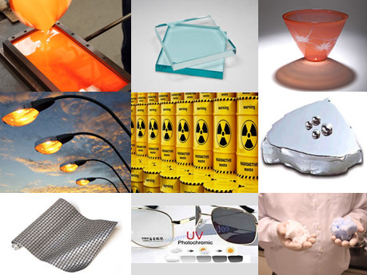
Submitted
To
The Materials Science and Engineering committee
In Partial Fulfillment for Professor Post

By
Safeya Ibrahim Abd El-Ghany
Assoc. Prof., Glass Dept. ,
National Research Centre,
33 El-Bohoth St. (Former El Tahrir St.), Dokki, Giza, P.O. 12622, Egypt.
December 2017
Contents
 |  | Page
 | Abstract ……………………….……………………………………………………………………… | 4
1. | Introduction ……………………………………………….………………………………………… | 5
2. | Glasses: compositions and preparation ………………………………………………… | 6
3. | Classification of glasses based on the chemical composition…………………. | 9
3.1. | Ordinary – amorphous glasses…………………………………………………………………. | 9
3.2. | Bioactive glass………………………………………………………………………………………….. | 9
3.3. | Glass–ceramics……………………………………………………………………………………….. | 9
3.4. | Metallic and chalcogenide glasses……………………………………. | 10
4. | Structure of inorganic oxide glasses……………………………………………………… | 10
4.1. | Silica and silicate glasses……………………………………………………………………….. .. | 10
4.2. | Multicomponent silicate glass………………………………………………………………….. | 11
4.3. | Borate glass……………………………………………………………………………………………. . | 12
4.4. | Phosphate glass……………………………………………………………………………………….. | 12
5. | Properties of glass…………………………………………………………………………………. | 13
6. | Types of various glasses based on their applications……………………………… | 14
7. | Advances in glass and glass–ceramics……………………………………………………. | 16
7.1. | Development in compositions………………………………………………………………... | 16
7.2. | Developments in applications………………………………………………………………….. | 17
7.2.1. | Glasses and solar energy…………………………………………………………………………. | 17
7.2.2. | Glasses and water purification…………………………………………………………………. | 18
7.2.3. | Glass for water desalination and hydrogen production……………………………. | 18
7.2.4. | Glasses for wind energy………………………………………………………………………….. | 19
7.2.5. | Fast ionic conduction glasses…………………………………………………………………. .. | 20
7.2.6. | Glasses as energy storage systems…………………………………………………………… | 20
7.2.7. | Glasses as immobilizers for nuclear wastes……………………………………………… | 23
7.2.8. | Glasses for Low-melting applications……………………………………………………….. | 23
7.2.8.1 | Solder glasses………………………………………………………………………………………….. | 23
7.2.8.2. | Overgrazing and enameling……………………………………………………………………… | 25
7.2.8.3. | Verification of high level radioactive waste……………………………………………… | 25
7.2.9. | Glasses and glass–ceramics for dental applications………………………………….. | 25
7.2.10. | Bioactive glass-ceramics…………………………………………………………………………… | 27
7.2.11. | Glass-ceramic for commercial applications………………………………………………. | 27
7.2.12. | Borat glasses for Scientific and industrial applications……………………………… | 28
7.2.12.1. | Low-pressure sodium vapor lamps…………………………………………………………… | 28
7.2.12. 2. | Borat glasses for biomedical applications………………………………………………. | 29
7.2.12.3. | Borat glasses for Radioactive waste immobilization, neutron and gamma-ray shielding…………………………………………………………………………………………….. | 31
7.2.12.4. | Borate glasses for optical fibers and optoelectronic applications …………..…. | 33
7.2.13. | Glasses as fertilizers………………………………………………………………………………… | 34
7.2.14. | Radiation sensitive glasses………………………………………………………………………. | 35
7.2.14.1. | Photosensitive glasses……………………………………………………………………………… | 35
7.2.14.2. | Photochromic glasses……………………………………………………………………………… | 36
7.2.14.3. | Glass for radiation dosimetry…………………………………………………………………… | 36
7.2.15. | Metallic and Chalcogenide glasses…………………………………………………………… | 37
8. | Contribution of Egyptian Researchers……………………………………………………. | 39
9. | Future directions and recommendations………………………………………………. | 39
 | References………………………………………………………………………………………....... | 41

Abstract

Glass is an amorphous commonly transparent and hard material. Therefore, it has been used in various applications. Glaze on ceramic was the first known type of glass, and the first plant for glass was in Egypt at Tell El-Amarna, south of Egypt. It subjected to many developments through that time till recent age. The old glass compositions were based on soda – Ca-silica then Na–Al glass appears till reached to N-containg glasses and certain compositions that able to crystallize to give what is known glass ceramics. The developed glasses and glass ceramics become essential needs in our life and in the industrial areas. Depending on the chemical composition glass and glass ceramics can be classified as: Ordinary – amorphous glasses, Bioactive glasses, Glass–ceramics, metallic glasses and Chalcogenide glasses. These materials are characterized by applicable mechanical and chemical in addition to electrical properties that enabled these materials to have a wide spectrum of applications. Applications of different types include : Float glass, tinted glass, Reflective glass, optical lenses, Enameles, photosensitive glass, Pattern glass , mirrors, Glass Wool, communication fibers, Optical lenses, glass for Photovoltaic, glass for X-ray protection, Electrically heated glass, Electrochromic glass, Liquid crystal glazing, Self-cleaning glass, Tempered glass, Fire-resistant glass, Sealing glass , Bioglass, Radiation sensitive glasses . Glass as a material will always exist in human life.

- Introduction
Glass products have applications in scientific field and design engineering, in which plastics and metals can not be used. After the discovery of glass it passes through the time with drastic changes and developments both in composition and applications.
The Roman sailor noticed that during, cooking their meal on a beach, which contains nature raw materials of sodium in addition to the sand grains, a liquid began to flow and that was the origin of man-made glass [1].
Glaze on ceramic was the first known type of glass, and the first plant for glass was in Egypt at Tell El-Amarna, south of Egypt (Fig.1) [2]. Glass manufacture based on soda lime glass was developed In Murano Island, near Venice. New glasses were developed where transparent glass, referred as glass–ceramics were used as cookware. In 1950s, a new revolutionary production method for float glass production was introduced followed by development of fiber glasses for laser communication in 1970s. Glasses that can immobilize radioactive wastes were also developed during the 1970s. [1]. Such progress in the development of glass since its discovery is continuing in the present time and become a part of our life as will be seen in the following items.
2. Glass: compositions and preparation
Glass is a solid material with a randomized three-dimensional structure called amorphous or glassy state which is characterized by XRD hump (Fig.2) and glass transition temperature (Fig.3) [3].
Glasses are prepared from oxides (Table 1) that introduced during fabrication as such or in other forms such as carbonates, hydroxides or salts where they are mixed and melted at a high temperature in the range 1100°C to 1550°C according to the composition of the glass. Essentially, these oxides reduce the melting temperature of the mixture because the silica sand has a softens near 1770 °C. The formed melt is shaped [4] and cooled to room temperature with certain rate in a process called “annealing” to avoid formation of strains in the glass articles.
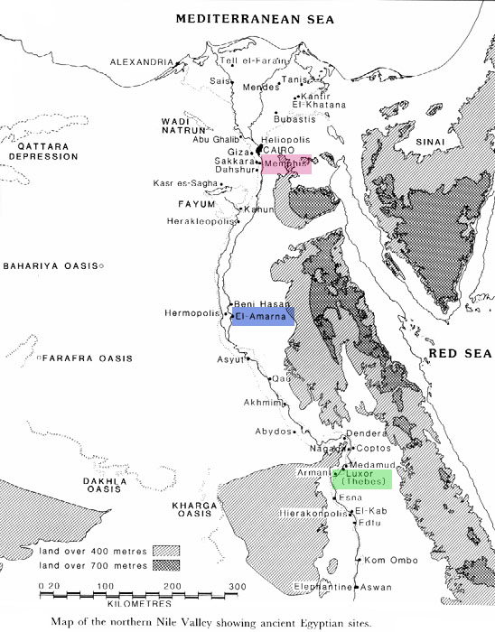

Fig.1 A map showing ancient Egyptian sites and Tell El-Amarna [2]
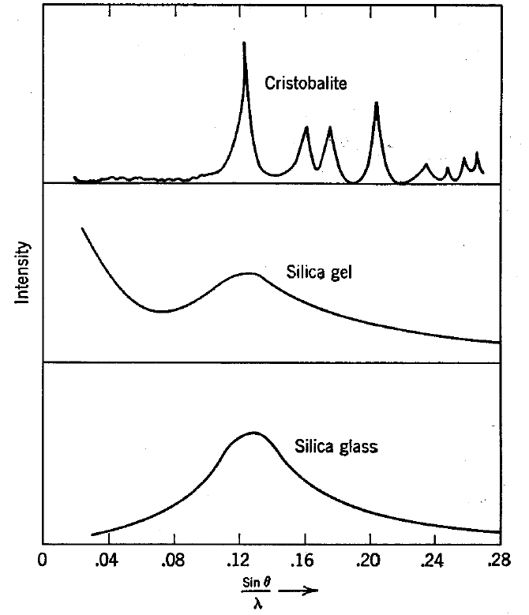

Fig. 2 X-ray diffraction patterns of cristobalite,  silica gel, and vitreous silica | Fig. 3 Volume –temperature relationships for glass, liquids, supercooled liquids and crystals

The above method of glass preparation is referred as"melt-quenching technique" (Fig. 4). Other techniques such as vapor deposition (CVD) and sol-gel processes are possible; however, the melt-quenching technique is the only method for obtaining bulk glasses of acceptable size [5, 6].

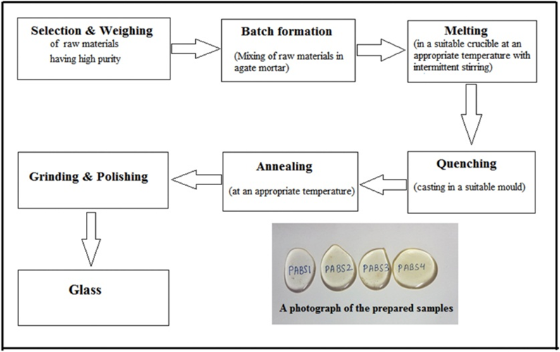

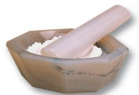
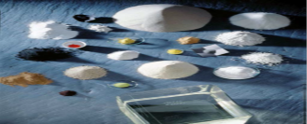
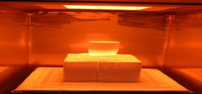

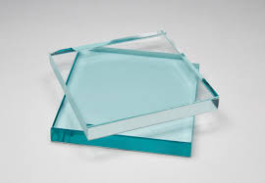
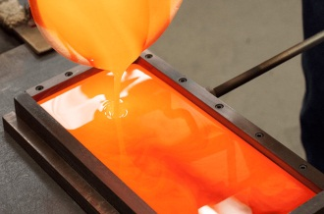

Fig. 4 Schematic illustration of melt quenching technique

Table 1 Oxides used in the fabrication of glass and their functions

No. | Oxide function | Oxide
1 | Main glass former oxides | SiO₂ , B₂O₃  GeO_{2,}P₂O₅
2 | Needs certain conditions to form glass | Al₂O₃; Bi₂O₃;  WO₃; MoO₃
3 | Intermediate oxides that form glass with former oxides | TiO₂; ZrO₂  PbO; ZnO;
4 | Modifier oxides: they modify the glass properties. | MgO, CaO, Na₂O,  K₂O

3. Classification of glasses based on the chemical composition
A simplified classification of glass and glass–ceramics based on their chemical composition is as follows:
3.1. Ordinary – amorphous glasses:
These glasses include: Silica glass, Na–Ca silicate glass, borate glass, borosilicate glass, lead silicate, alumina silicate, Bi- silicate glass, Ca-B-Al glass, phosphate glass and Germanium glass. These glasses are of high commercial spectrum. Commercial glasses are based on silica sand and raw materials for oxides (Table 1) of different functions such as Na₂O and CaO.
3.2. Bioactive glasses:
Bioactive glasses are type of glasses that when in contact with body tissues, develops layers between the implant glass and host tissue. They mostly contain SiO₂, P₂O₅, CaO, MgO and alkali oxides. The reaction rate of the bioactive glass with the contact tissues is controlled by changing its the chemical composition, which enables its usage for clinical applications [7].
3.3. Glass–ceramics:
Glass–ceramics are made by controlled crystallization of specially formulated compositions that may contain nucleating agents such as TiO₂, ZrO₂, P₂O₅ that initiate the crystallization process [8]. These types of materials are applicable in high temperature conditions. Their excellent mechanical and physical properties permit the usage of these types for industrial applications and as electrical insulators [4].

3.4. Metallic and chalcogenide glasses:
Bulk metallic glasses (MGs) are considered as materials from metals with disorder structure. Chalcogenide glasses are glasses that contain one or more of the elements sulfur, selenium and tellurium in disorder structure with covalent bonding. They are prepared from the liquid state by too fast cooling such that no crystals are formed and the material remained in the glassy state. They are commonly referred as ‘‘metallic glasses’’ or ‘‘bulk metallic glasses’’. The metallic glass Pd–Cu–Si and Pd–Ni–P alloys were prepared by melting and quenching in water. Amorphous steel have been introduced with higher strengths than conventional steel. The characteristic properties of these glassy alloys are they became soft and flow upon heating. Therefore they are easily processed, such as by injection molding, in similar manner as polymers. Bulk metallic glasses have found applications in medical devices, and as cases for electronic equipment [4].
4. Structure of inorganic oxide glasses

4.1. Silica and silicate glasses

Fig. 5 shows the network units of silica glasses.

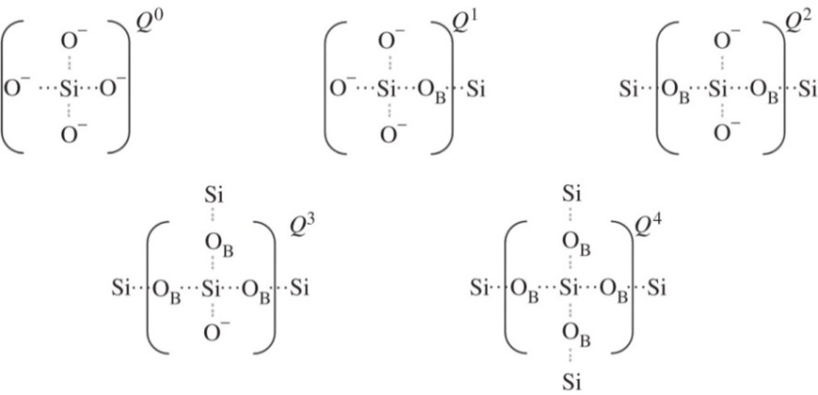
Fig. 5 Network units of silicate glasses

4.2. Multicomponent silicate glass:

Fig.6 shows two-dimensional schematic representation of (a) a crystalline structure of quartz; (b) a simple silica glass; and (c) a multicomponent silicate glass.

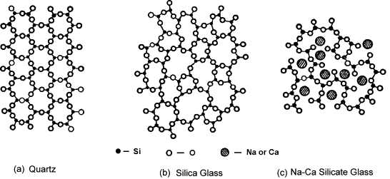
Fig.6 Two-dimensional schematic representation of (a) a crystalline structure of quartz; (b) a simple silica glass; and (c) a multicomponent silicate glass[9]
4.3. Borate glass
In borate glasses several group structures may be formed(Fig.7): the isolated diborate ${\left(B_{4}O_{7}\right)}^{2-}$ groups, loose diborate , chain or ring type meta- and pentaborate ${\left(B_{5}O_{8}\right)}^{-}$groups, six-member boraterings with one or two $BO_{3}$ triangles replaced by a ${\left(BO_{4}\right)}^{-}$ tetrahedral, boroxol rings, triborat${\left(B_{3}O_{5}\right)}^{-}$, tetra-borate${\left(B_{8}O_{13}\right)}^{2-}$, ortho-borate${\left(BO_{3}\right)}^{3-}$, pyroborate${\left(B_{2}O_{5}\right)}^{4-}$groups and linked ${\left(BO_{3}\right)}^{3-}$ triangles with onefree vertex[10,11]. Examples of such groups are shown in (Fig.8).
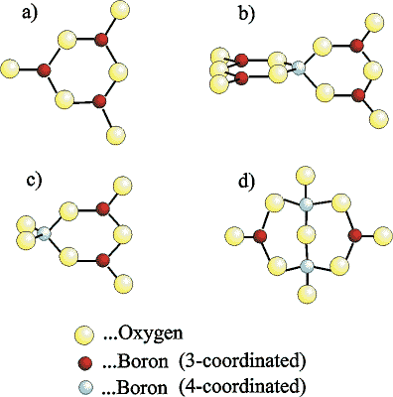

Fig.7 Some network units of borate glasses: a) boroxol,
b) pentaborate, c) triborate and d) diborate groups

4.4. Phosphate glass

The structural groups of phosphate glasses are shown in Fig.8.

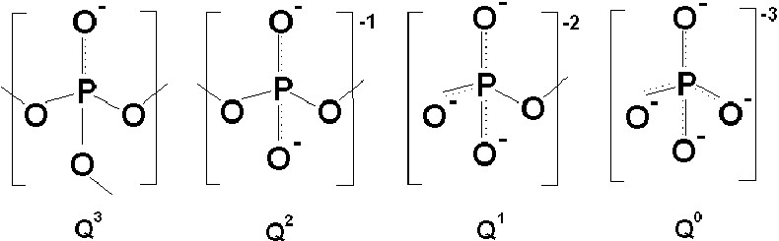

Fig. 8 Structural groups in phosphate glasses [12]

5. Properties of glass
Generally, the chemical composition of the glass essentially determines its mechanical and physical properties. The most important properties of glass are: the hardness is high (more than metals),high tensile strength ( 24–69 MPa), they are brittle yet with low ductility, have both low coefficient of thermal expansion and low coefficient of thermal conductivity, considered as electrical insulators and resist most chemicals , solvents and acidic and alkaline solution and some types resist variation in temperature . Tables 2and 3 list a comparison of some selected properties of other materials with glassy materials [4].

Table 2 Mechanical properties of glasses in comparison with other engineering materials.

Material | Flexural  strength  (MPa) | Compressive  strength  (MPa) | Hardness,  HV | Young modulus  of elasticity,  E (GPa)
Amorphous silica glass | 98 | 1860 | 600 | 69
Crystalline glass–ceramic | 103 | 344 | 250 | 64
Plastic (polycarbonate) | 89. 6 |  |  | 2.28
Carbon steel | 275 | 275 | 100 | 200
Cemented carbide | 1400 | 4000 | 1000 | 612

Table 3 Physical properties of glasses in comparison with other engineering materials.

Material | Density  (kg/m³) | Thermal conductivity  (W/m °C) | Coefficient of thermal  expansion, 20–100 °C  (x10⁻⁶ m/m °C) | Electrical  resistivity  ($Ω$m)
Silica (amorphous glass) | 2304 | 34 | 1 | 10⁷
Crystalline glass–ceramic | 2592 | 33 | 9.4 | 10¹²
Plastic (polycarbonate) | 1296 | 0.2 | 6.7 | 8x10¹⁴
Carbon steel | 8064 | 47 | 11.9 | 20
Cemented carbide | 16000 | 86 | 7.4 | 6x10⁻⁸

The optical properties of glasses permit their application for lenses and windows. High silica glasses are characterized by very low coefficient of thermal expansion, which makes them resistant for thermal shocks suitable for laboratory glass instruments and light bulbs. Glass ceramics have good shock resistance.
6. Types of various glasses based on their applications
Types of glasses are numerous , starting from float glass to security types to special glass types like electrochromic and photovoltaic glass are listed in (Table. 4) with some areas of their application; such as Automotive , construction, Physics, chemistry and electronic applications. More details about the famous applications of these types are given in item (7).
7. Developments in glass and glass–ceramics
7.1. Development in Compositions
Hampshire [13] revealed some advances in the domain of oxynitride glasses. The nitrogen content and also cation ratios were found to affect drastically the structural of the glass, consequently its properties. The main conclusions were oxynitride glasses based on the systems M–Si–O–N, M–Si–Al–O–N and M–Si–Mg–O–N can be prepared by normal melting processes. As nitrogen content increases, properties such as the hardness increases while thermal expansion coefficient decreases due to the increase in cross-linking of nitrogen within the glass network. The chemical durability and physical and mechanical properties of phosphate glasses were increased as a result of dissolved Nitrogen in those glasses [13]. Fujimoto [14] describes a new infrared luminescence from bismuth (Bi)-doped glass which found applications such as laser oscillation [[14] or optical amplification [15].
The applications of glasses were extended as a result of development of their compositions where glasses for windows or bottles were developed to suite antinuclear radiation containers or in machine controls by using photosensitive glasses, or for imaging technologies and energy-saving [16].
Revolutionary flexible glass-ceramic material, such as LaZr₂O₇ (LZO) and Yttrium silicate
(Y₂SiO₅ known, as (ZircoFlex)), was developed to be used as heat shield material. The ceramic material being sprayed onto surfaces of the aluminum backing foils (see Fig. 9). Such applications for ZircoFlex™ are used in automotive industry to protect sensitive components from heat [4].

Table 4 Types of various glasses and areas of applications.

General classification | Type of glass | Automotive | Aerospace,  Architecture, construction | Physics  /chemistry/  electronics
Common glasses | Float glass |  | X
Common glasses | Body tinted glass |  | x
Common glasses | Reflective glass | x |  | x
Common glasses | Enamels |  | x
Common glasses | Pattern glass |  | x | x
Common glasses | Mirror |  | x
Common glasses | Glass Wool
Common glasses | Glass fibers
Common glasses | Optical glass
Common glasses
  Sealing glass | x
Special glass types | Photovoltaic glass | x | x | X
Special glass types | Glass for X-ray protection | X | x | x
Special glass types | Electrically heated glass | X | x | x
Special glass types | Electrochromic glass | x | x | X
Special glass types | Liquid crystal glazing | x |  | x
Special glass types | Self-cleaning glass | x | x | x
Special glass types | Sand-blasted glass |  | x
Special glass types | Acid-etched glass |  | x | x
Special glass types | Tempered glass | x | x | x
Special glass types | Laminated glass | x | x | x
Special glass types | Fire-resistant glass | x | x | x
Special glass types | Wired glass | x | x | x
Special glass types | Alarm glass | x | x | x
Special glass types | Antireflective glass | x | x | x
Special glass types | Bioglass |  |  | x
 | Radiation sensitive glasses |  | x | x

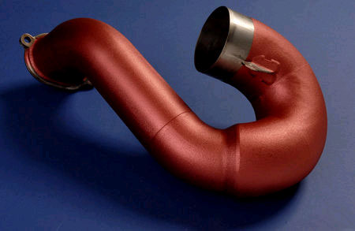
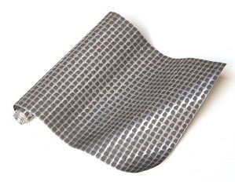

(a) (b)

Fig. 9 Flexible ceramic ZircoFlex™ on Al-foil (a) and on a steel (b)[4]
7.2. Developments in applications
7.2.1. Glasses and solar energy
Solar energy systems (Fig .10) include photochemical reactions and their scales vary from large plant to small portable units [16]. Solar systems are improved by introducing crystalline, semiconductor nanostructures materials, such as CdSe/ZnS. These materials absorb light and emit photons of lower frequencies. Solar collectors can be integrated in building facades (Fig.10).

Fig. 10 Solar energy systems
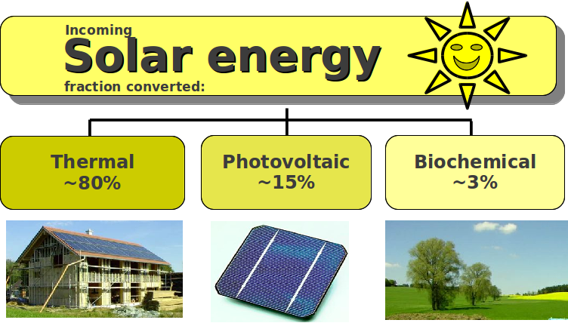

7.2.2. Glasses and water purification
Glass as substrates makes use of solar energy to be used for photo catalytic decontamination in water or as tubes to carryout desalination as well. The photo catalytic process is performed on the glass surface on which titania was deposited. To facilitate the conductivity, indium doped tin oxide being painted on the glass surface. Glass surfaces are used due to their transparency to UV- light [4].
7.2.3. Glass for water desalination and hydrogen production
Solar collection systems should include glass covers that are transparent to solar light and to act as condensation surfaces in single or double basin solar stills (Fig. 11a ) [16]. Amorphous silicone carbide (SiC:H) was used as photo electrode (Fig. 11b ) for production of hydrogen by solar energy [17].

(a)
.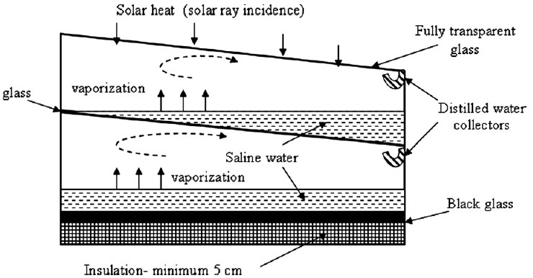

(b)

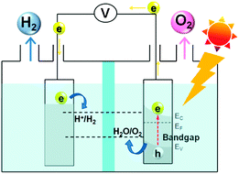

Fig. 11 (a) Double basin solar still for desalination (adapted and modiﬁed from and [16]),
(b) Principles of photo electrode for hydrogen production [17].
7.2.4. Glasses for wind energy
The production of energy from winds include a wind turbine attached to three blades (Fig. 12) made of fiber glass/resin composite material. The presence of these glass fibers is to provide ultra-high strength, high-modulus glass compositions for these applications [18]. Fibers made of basalt or E-glass fibers can be used for this application.

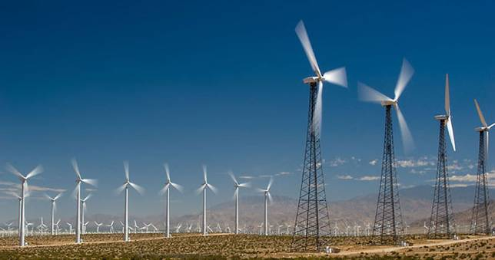
Fig. 12 Wind energy system
7.2.5. Fast ionic conduction glasses

These glassy materials (Table 4) are used as solid electrolytes in batteries, or as sensors or electrochromic displays [19]. Their constitutions include various oxides of glass former with oxides of silver, lithium, sodium and potassium and chloride, iodide, bromide or fluoride salts [20–24].
7.2.6. Glasses as energy storage systems

Glass and Glass–ceramics may act as dielectric materials in super-capacitors to store energy or act as electrolytes in solid oxide fuel cells or in lithium batteries [26]. Super-capacitors of lithium aluminum silicate glass–ceramic with ZrO₂ and TiO₂ nucleating agents were developed [27].
Hydrogen gas as fuel for a clean energy can safely store in hollow glass micro-spheres (Fig .13). Glass as storage material for hydrogen is cheap, strong and non-explosive material. Furthermore it can be recycled [16].

Table 4 Some important cation (Ag⁺, Li⁺, Na⁺, Cu⁺) & anion (F⁻) conducting glasses along with their conductivity values[25].
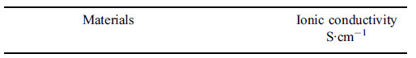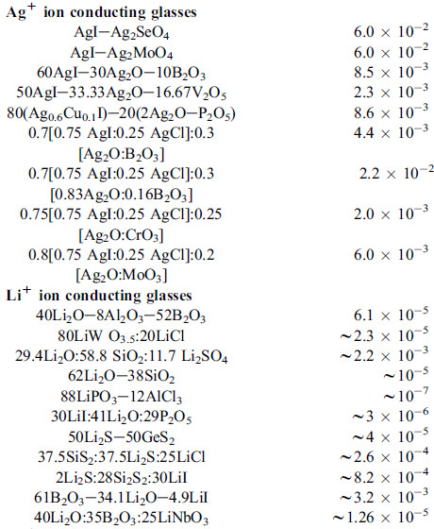
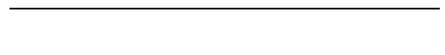

Table 4 ( Continued).
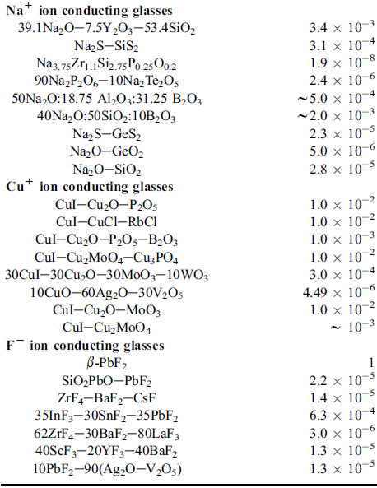

7.2.7. Glasses as immobilizers for nuclear wastes
Glass is the material l of choice for waste forms safely stores the radioactive materials. It is prepared with compositions that impart high chemical and mechanical properties that make stable towards radiation and high temperature. Generally, borosilicate glass is one of the types of glasses which are used as immobilizers.
Radioactive waste materials are immobilized by mixing it with a frit of borosilicate glass then they are melted at temperature below 1200 °C. The melt is cast into stainless steel containers that are welded shut, and moved to geological repositories (Fig. 14) [28].
As an alternative for nuclear waste immobilizers Iron phosphate glasses are used. It has been found that chemical and mechanical properties of iron phosphate glasses are better than that of borosilicate (Fig. 15) [4].
7.2.8. Glasses for Low-melting applications

7.2.8.1. Solder glasses
These type of glasses are characterized by low melting temperature they also called
sealing glasses. Their softening temperatures are generally below 550 °C that permits their application in sealing, as insulating coatings and enameling purposes. The compositions of most of commercial solder glasses were based on lead-containing compositions. Recently, Ca-aluminoborate and borosilicate of compositions (Wt %) 41.24 B₂O-30.2Al₂O₃-11.94 MgO- 16.62CaO and 8.0 B₂O -20.0 Al₂O₃ -4.95 SiO₂-7.0MgO-12.0CaO- 6.0SrO- 2.0 La₂O₃ – 0.05 CoO, respectively, were developed [30]. However, the industry forced to use lead-free compositions due to the toxicity of PbO [31].

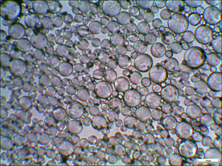
Fig .13 Hollow glass microspheres

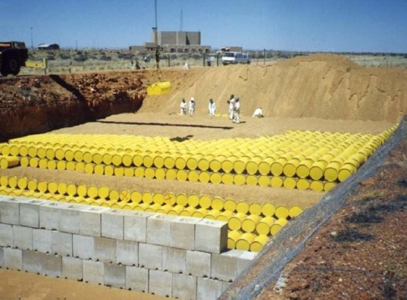
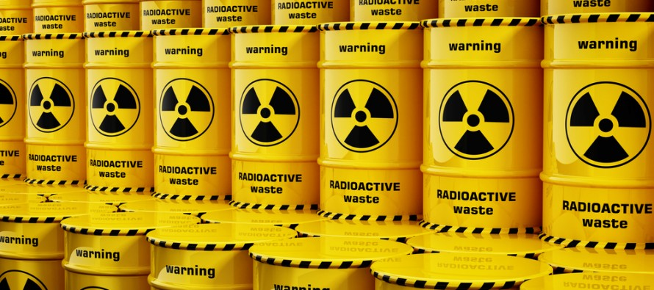

Fig.14 Storage of High-Level Radioactive Nuclear Waste

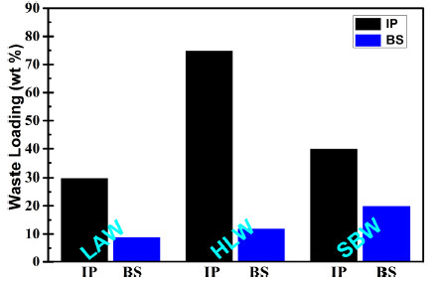

Fig.15 A comparison of the waste loading achieved in iron phosphate (IP) and that calculated for borosilicate (BS) glass waste forms for three nuclear wastes [29],
(LAW)=low-activity waste, (HLW) = high level waste, (SBW)= sodium bearing waste

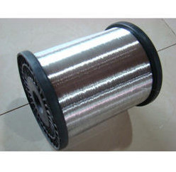

Fig. 16 Enameling of aluminum

7.2.8.2. Overgrazing and enameling
These glasses, such as borophosphate ones, are characterized by low temperature melting and can be used for overgrazing of ceramic articles and enameling of aluminum (Fig. 16) [32-38].
7.2.8.3. Vitrification of high level radioactive waste

High level radioactive wastes are immobilized in Lead iron phosphate glasses [39-41]. Other systems based on SnO–ZnO–P₂O_{5,} alumino-phosphate and borophosphate systems were also developed [42- 47].
7.2.9. Glasses and glass–ceramics for dental applications
Glass ceramics are based on glasses that can be crystallized by controlled crystallization to achieve certain properties suitable for medical application [48-50].
Glass-ceramics with varied compositions have been developed to be used in dentistry [51]. After using of lithium disilicate glass-ceramic, leucite glass-ceramics were used [52]. However, lithium disilicate-based materials have better mechanical properties (Table 5), therefore they applied to the production of all-ceramic fixed partial dentures (Fig. 17) [53]. The first lithium disilicate glass-ceramic (based on the system Li₂O:2SiO₂) (Table 6) was produced by melting , which was then ground to be used in the form a powder [54].

Fig. 17 Glass-ceramic teeth lithium disilicate glass-ceramics
are ideal for fabricating single-tooth restorations [55].

Table 5 Mechanical properties for the traditional glass ceramics in the market [56-58].
Material | Flexural strength  (MPa) | Fracture toughness  (MPa.m^{1/2}) | Hardness  (GPa)
Leucite | 164 | 1.03 | 6.5
Lithium disilicate | 365 | 2.80 | 5.3

Table 6 Composition of the glass-ceramic lithium raw powder [54]
Constituent | SiO₂ | Al₂O₃ | La₂O₃ | MgO | ZnO | K₂O | Li₂O | P₂O₅ | Additives
Weight % | 57–80 | 0–5 | 0.1–6 | 0–5 | 0–8 | 0–13 | 11–19 | 0–11 | ~ 8

Yttria stabilized tetragonal zirconia polycrystal (Y-TZP) was developed and used for full-contour crowns restorations for monolithic (full-contour) restorations [50, 59, 60].
7.2.10. Bioactive glass-ceramics
Certain glass-ceramic has bioactive properties and when implanted in human body a biologically active layer of hydroxyl apatite is formed and bonds to bone and teeth. They can be used for where high mechanical properties are required (such as as small-bone replacements).
A type of highly bioactive glass-ceramic based on the Na₂O-CaO-SiO₂-P₂O₅ and contained about 30 to 50 percent crystalline phase of Na₂O∙2CaO∙3SiO₂ was developed [61].
Heat-generating types of bioactive glass-ceramics were used in hyperthermic treatment of tumors. For instance, one based on the chemical composition CaO–SiO₂–Fe₂O₃–B₂O₃–P₂O₅ was developed [62].
7.2.11. Glass-ceramic for commercial applications
A Glass ceramic was developed to be used in the aerospace industry as radomes to protect radar equipment in the nosecones of aircraft and rockets. No glass or metal can y meet all of the specifications needed for these applications [63].
Fotoceram is a type of glass ceramics which can be patterned by ultraviolet light and selectively crystallized by thermal treatments. The products can be applied in areas that need microchannels, ink-jet printer heads and acoustic systems in head-phones [63–67].
A range of glass-ceramics (in the system the Li₂O–Al₂O₃–SiO₂ (LAS) system) for consumer applications include those materials that resist thermal shock. LAS glass-ceramics can resists quick temperature changes of 800 °C to 1000 °C [55].
The glass ceramic can be used as electrically insulating materials, transparent glass-ceramics: cookware and as bullet-proof vests. Machinable glass-ceramics can be shaped with ordinary metalworking tools. Glass ceramic can be used as construction materials for floor and wall tile [55, 66-68].
7.2.12. Borat glasses for Scientific and industrial applications
There are certain circumstances where silicate and borosilicate glasses are not satisfactory for scientific and industrial needs. Borate glasses offer certain advantages over silicate glasses that satisfy certain application as seen bellow.
7.2.12.1. Low-pressure sodium vapor lamps
These types of lamps should be made from specific glass materials than not affected by sodium vapor. Therefor Silicate glasses are not suitable for this purpose (Fig.18). Special glasses were developed and lamps of Low-pressure sodium vapor were to illuminate some streets in south London [69, 70].
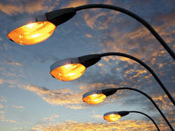
Fig.18 sodium vapor lamps

7.2.12. 2. Borat glasses for biomedical applications
Certain borate glasses (Table 7) may have biodegradable (or bioresorbable) properties. These types of glass dissolve in human bodies when implanted to regenerate an intended tissue [71]. Another potential application of biodegradable glass is controlled drug delivery [72].
Nanofibers glasses based on the compositions 51.5–53 % B₂O₃, 20 % CaO, 6 % Na₂O, 12 % K₂O, 4 % P₂O₅, 5 % MgO, 0–0.4 % CuO, and 0–1 % ZnO (in wt%) and supported on small - size bandage were used as wound healing (Fig. 19) [73-75].
A glass used in biomedical field as antimicrobial material, based on the composition 40–80 % B₂O₃, 0–70 % P₂O₅, 0–30 %Al₂O₃, 0–12 %Li₂O, Na₂O, K₂O, and 1–30 %Ag₂O (wt%), was developed [75]. One of the biomedical applications of such glass powders is antimicrobial additives for teeth restoration materials [76].
Table 7 Borate glass compositions developed for biomedical applications [30]
Composition (mol %) | 13-93B1ª | 13-93B^{3b} | 13-93B3/  D-Alk-3B^{a,b} | 2B–6Sr^{b} | 2B–12Sr^{b} | H6Bª | B18ª | H12ª
Na₂O | 6.0 | 6.0 | 6.0/5.9 | 6.6 | 6.7 | 15.0 | 12.5 | 8.0
K₂O | 7.9 | 8.0 | 8.0/7.9 | 7.1 | 6.9 | – | – | –
MgO | 7.7 | 8.0 | 8.0/7.7 | 1.9 | – | – | – | –
CaO | 22.3 | 22.0 | 22.0/22.2 | 21.8 | 17.7 | 35.0 | 35.0 | 40.0
SrO | – | – | – | 5.8 | 11.6 | – | – | –
Al₂O₃ | – | – | – | – | – | 1.0 | 3.5 | 2.0
SiO₂ | 36.3 | – | – | 19.2 | 18.8 | 6.5 | 6.5 | 7.5
P₂O₅ | 1.6 | 2.0 | 2.0/1.7 | 1.8 | 1.9 | 1.0 | 1.0 | 2.5
B₂O₃ | 18.2 | 54.0 | 54.0/54.6 | 35.8 | 36.4 | 41.5 | 41.5 | 40.0

a Measured composition b Nominal composition

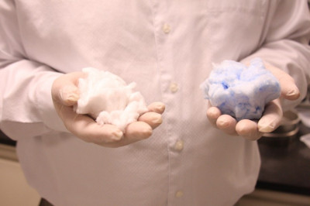
(a)
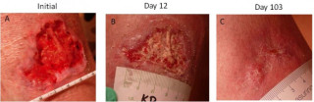
(b)
Fig. 19 A glass nanofiber material that looks like cotton candy (a), has been shown to speed healing in difficult-to-treat wounds and (b)a special borate-based glass nanofibers with ads used for wounds healing.

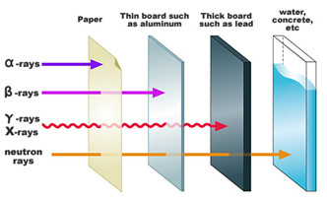
Fig.20 Radiation types and the degree of penetration

7.2.12.3. Borat glasses for Radioactive waste immobilization, neutron and gamma-ray shielding
Currently, gamma, X rays and neutrons are used in some applications, e.g., food irradiation. Long exposure to these radiations which have high penetration (Fig.20) may cause dangerous diseases as cancer. Therefore it is important to select suitable shielding materials to protect people from these harmful radiations [77].
Efforts have been made to use borate glasses for immobilization of radioactive waste [78–80]. CaBAl glass was studied for this purpose [78], yet, borophosphate glasses [79] and lead borate glasses [80] were found to be more successful. Lead borate glasses bismuth borate glasses (60Bi₂O₃–40B₂O₃) have good shielding effect for gamma –irradiation [81, 82]. For neutron shielding [81] borate glasses in the system (100 − x − y) Na₂B₄O₇−xPbO−yNiO were developed [81]. Borate glasses high in cadmium oxide are considered as good slow-neutron absorbers [83]. Table 8 list further glass systems applied for radiation shielding [84].
7.2.12.4. Borate glasses for optical fibers and optoelectronic applications
Borate glass can dissolve large concentrations of the rare earth elements such as La₂O₃, Nd₂O₃, and Sm₂O₃ [85]. This property enabled the development of special borate glass based on the composition (TeO₂)_{0.7}(B₂O₃)_{0.3}]_{0.7}(ZnO)_{0.3}}_{1−x} (La₂O₃ NPs)_{x}, where = 0.01, 0.02, 0.03, 0.04, and 0.05 molar fraction, is developed to be used as optical fibers [86] [87], in photonics devices [88], telecommunication [89] and for near-infrared fiber amplifiers [90]. Borate glasses have application in geological dating and personal radiation dosimetry [91]. Barium aluminoborate is developed for such application using luminescence technology [92].

Table 8 Borate and phosphate glass systems applied for radiation shielding
and year of their development [84].

Years | Glass compositions
1986 | Pb-In P₂O₅ and Pb-ScP₂O₅ glasses
2002 | xBi₂O₃-(1-x)B₂O₃ -xBi₂O₃-(1-x)B₂O₃
2003 | ZnO-PbO-B₂O₃ glass systems
2005 | High Pb-P₂O₅ glasses
2006 | xPbO-(0.5-x)BaO-0.5B₂O₃
2008 | BaO-B₂O₃-Flyash  xPbO-(1-x)SiO₂
2009 | xPbO-(100-x)B₂O₃
2011 | BaO-B₂O₃-Flyash  lead sodium borate glass systems
2012 | BaO-B₂O₃-Rice huck Ash  BaO-B₂O₃-Flyash glasses  BaO-Bi₂O₃–Borosilicate  BaO doped SiO₂-B₂O₃-Al₂O₃-Na₂O glass systems  P₂O₅-PbO-BaO
2013 | Ba²⁺Cations doped Fe-Na P₂O₅ Glasses  (50-x)SiO₂-15B₂O₃-2Al₂O₃-10CaO-23Na₂O-xBi₂O₃  xLi₂O-(50-x)B₂O₃-40PbO-10P₂O₅  Pb-Zn-B₂O₃glasses
2014 | xBaO-5ZnO-5MgO-14Na₂O-Li₂O-(75-x)B₂O₃  10ZnO-xBi₂O₃-(90-x)B₂O₃  xPbO-(0.90-x)B₂O₃-0.10Al₂O₃
2015 | PbO-BaO-P₂O₅ glass systems

7.2.13. Glasses as fertilizers

Glasses in the system SiO₂-P₂O₅-K₂O-MgO-CaO-MnO2 were synthesized by the melt-quenching technique. Increasing amount of MnO₂ result in an increase in the degree of de-polymerization of the structure which enable the use of this type of glass as fertilizer for providing the soil with Mg , K , Ca, P and Mn ions (Fig. 21) [93].

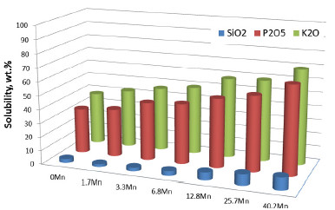
Fig.21 Solubility of the chemical selected components of
silicate–phosphate glasses, in citric acid solution.

7.2.14. Radiation sensitive glasses
This type of glasses includes: Photosensitive glasses, photocromic and Glass for radiation dosimetry.
7.2.14.1. Photosensitive glasses
Photosensitive glasses are crystal-clear glasses that belong to silicate glasses containing Li₂O that form lithium- metasilicate around metallic cooper formed by photochemical reaction followed by controlled heating . The formed lithium- metasilicate is removed by etching in HF acid, accordingly when a selective photochemical reactions are performed, these positions will be etched leaving the other regions unaffected (Fig. 23). Photosensitive glass is used in printing and decoration [94-96].

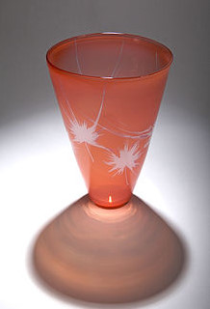
Fig. 22 Photosensitive glass
7.2.14.2. Photochromic glasses
Photochromic glasses are type of glasses that affect by light. Upon exposure to light the transparency of the glass decreases, on the other hand when the light is removed the original transparency is restored (Fig.23). This type of glass can be used as a simple smart window; its transmittance is dimmed upon solar illumination but returns to its original value in the dark similar to photo reactive sunglasses [97].

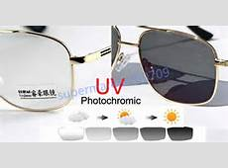
Fig.23 Photochromic glasses

7.2.14.3. Glass for radiation dosimetry
Glasses for dosimetry using thermoluminescence method based on Lithium borate glass systems co-doped with the oxides of dysprosium (Dy₂O₃) were studied One of the glass compositions is 30Li₂O:70B₂O₃, 30Li₂O:70B₂O₃:Dy₂O₃, and Li₂B₄O₇:Dy₂O₃. [98].
7.2.15. Metallic and Chalcogenide glasses
Metallic glasses (Fig.24) represent an essential milestone engineering materials for its high mechanical and magnetic properties [99-101]. Above their glass transition, metallic glasses exhibit unique softening behavior which enables these glasses to act as thermoplastics. Metallic glasses can be shaped into very small size articles [102]. Some of these glasses (Mg₆₀Zn₃₅Ca₅) are used for implantation as screws into bones [103]. Ti-based metallic glasses are also used for this purpose. Other types of Ca or Zn or Sr-based metallic glasses are applied as biodegradable material for bones fracture repair [104]. Types with high magnetic and corrosion resistance properties of compositions based on Nd–Fe–Al alloys [105] Zirconium-based glasses, respectively, were also developed [106].

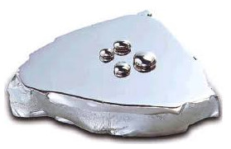
Fig.24 Metallic glasses

The composition of chalcogenide glasses are based on S, Se or/and Te elements with other elements such as As, Ge, P, Sb, Ga, In, Tl, lanthanides [107]. These glasses are new category of non-crystalline solids with covalent bonds, semiconducting and photosensitive properties [108]. Chalcogenide glasses for optical and Fibers applications of different systems have been developed [109-111].
8. Contribution of Egyptian Researchers
In Egypt a lot of work has been performed to develop and characterize different typs of glasses. At the NRC a lot of researches have been performed to prepare and characterize different glasses ( silicate, borate, phosphate and borophosphate ) and glass-ceramics as candidate for energy storage material [112-115], shielding material for gamma radiation [116 ,117], radiation dosimetry [118,119] ,dielectric materials [120] , optical applications [121], biomaterials [122,123].
At Alexandria University, Faculty of Science, tellurite glasses were developed [124 , 125].
At Al Azhar University, Faculty of Science borosilicate glasses were studied for Ultrasonic and smart windows applications [126, 127]. At Ain Shams University glasses for photonic applications were studied [128]. At Faculty of Science, Mansoura University, bioactive based tellurite and silicate glasses were developed [129] .Optical glasses were also developed [130]. At Faculty of Science, Menofia University glasses for optical and Luminescence applications were studied [131, 132]. At Benha University glasses for dielectric and laser were studied [133, 134]
9. Future directions and recommendations
Researches to improve deficiencies in borate glasses due to their low chemical properties should be increased. Binary borate glasses with lead oxide seem to be chemically durable, yet this oxide is toxic and should be removed and alternative glasses should be applied. Ternary and more complex borate glasses are needed for advanced applications. Glass as a material for many new applications will be involved in combination with other materials. With the increasing sophistication of optoelectronic devices, there is an increasing need to combine optical and electronic devices for many applications such as transmission of audio, video, and data information. Increasing attention should be towards glass ceramics as thermal shielding. The applications of flexible ceramic as heat shield material will increase. Increasing attention should be towards ‘‘smart glasses’’ to reduce the energy consumption in the buildings by energy-preserving techniques. Sufficient attention should be directed towards glass research in fields that in relation to useful application for the human community.

References
1 | L. Dussubieux, B. Gratuze, M. Blet-Lemarqu, Mineral soda alumina glass: occurrence and meaning, J. Archaeol. Sci. 37(2010)1646–1655.
2 | P.T. Nicholson , C.M. Jackson, Tell El-Amarna and the glassmakers, Workshop of the 2ndMillenium BC, La route du verre, TMO 33, Maison de I Orient, Lyon (2000)
3 | B. E. Warren, The Basic Principles Involved in the Glassy State, J. Appl. Phys.13 (1942) 602-610.
4 | E. Axinte, Glasses as engineering materials: A review, Mater. Des. 32 (2011) 1717–1732.
5 | P. Kaur, D. Singh, T. Singh, Heavy metal oxides glasses as gamma rays shielding, Nucl. Eng. Des. 307 (2016) 364–376.
6 | M.H. Kharita, R. Jabra, S. Yousef, T. Samaan, Shielding properties of lead and barium phosphate glasses, Radiat. Phys. Chem. 81(2012)1568–1571.
7 | GK. Budinski, MK. Budinski, Engineering materials – properties and selection.8th ed. New Jersey (US): Pearson International Edition, Pearson-Prentice Hall (2005).
8 | H.Y länen , K. H. Karlsson, A. Itälä, H. T. Aro, Effect of immersion in SBF on porous bioactive bodies made by sintering bioactive glass microspheres, Journal of Non-Crystalline Solids 275 (2000) 107-115.
9 | S. Caijun, Corrosion of Glasses and Expansion Mechanism of Concrete Containing Waste Glasses as Aggregates, journal of Materials in Civil Engineering 21(2009).
10 | C. R. Gautam, A. K. Yadav, A Review on Infrared Spectroscopy of Borate Glasses with Effects of Different Additives, ISRN Ceram. 2012(2012)1–17.
11 | P. G. Pavani, K. Sadhana, V. C. Mouli, Optical, physical and structural studies of boro-zinc tellurite glasses, Phys. B 406(2011)1242-1247.
12 | R. Lakshmikantha, R. Rajaramakrishna, R.V. Anavekar, N.H. Ayachit, Characterization and structural studies of vanadium doped lithium–barium–phosphate glasses, Canadian Journal of Physics 90(2012) 235-239.
13 | S. Hampshire, Oxynitride glasses, J. Eur. Ceram. Soc. 28(2008)1475–1483.
14 | Y. Fujimoto, New infrared luminescence from Bi-doped glasses. In: Mikhail Grishin, editor. Advances in solid state lasers development and applications. INTECH; February, (2010) ISBN: 978-953-7619-80-0.
15 | Y.S. Seo, Y. Fujimoto, Bismuth-doped Silica fiber amplifier. In: Bishnu Pal, editor. Frontiers in guided wave optics and optoelectronics, INTECH (2010) ISBN: 978-953-7619-82-4
16 | R. K. Brow, M. L. Schmitt, A survey of energy and environmental applications of glass. J. Eur. Ceram. Soc. 29(2009)1193–1201.
17 | F. Zhu, J. Hu, I. Matulionis, T. Deutsch, N .Gaillard, A. Kunrath, Amorphous silicon carbide photoelectrode for hydrogen production directly from water using sunlight, Philos. Mag. 89(2009) 2723–2739.
18 | B. Wei, H .Cao, S. Song, Tensile behavior contrast of basalt and glass fibers after chemical treatment, Mater Des 31(2010)4244–50.
19 | S. Bhattacharya, A. Ghosh, Relaxation of silver ions in superionic borate glasses, Chem. Phys. Lett. 424(2006)295-299.
20 | M. E. Masoud, M. Khairy, M.A. Mousa, Electrical properties of fast ion conducting silver based borate glasses, J. Alloys Compd.569 (2013) 150–155.
21 | D. Dutta, A.A Ghosh, Dynamics of Ag⁺ ions in binary tellurite glasses, Phys. Rev. B 72 (2005)024201.
22 | P. Kumar, S. Yashonath, Ionic conduction in the solid state, J. Chem. Sci. 118 (2006)135-154.
23 | E. Barsoukov, J.R. Macdonald, Impedance Spectroscopy, Wiley-Interscience, 2nd Ed.(2005).
24 | R.C. Agrawal, A. Chandra, A. Bhatt, Y.K. Mahipal, Investigations on ion transport properties of and battery discharge characteristic studies on hot-pressed Ag⁺-ion-conducting nano-composite polymer electrolytes: (1–x) [90PEO : 10AgNO₃] : xSiO₂,J. Phys. D.: Appl. Phys. 40 (2007)4714.
25 | A. Chandra, A. Bhatt, A. Chandra, Ion Conduction in Superionic Glassy Electrolytes: An Overview J. Mater. Sci. Technol. 29(2013)193-208.
26 | A. Goel, M.J. Pascual, J.M.F. Ferreira, Stable glass–ceramic sealants for solid oxide fuel cells: Influence of Bi₂O₃ doping, Int J Hydrogen Energy 35(2010)6911–6923.
27 | H. Anmin, L. Ming, M. Dali, Controlled crystallization of glass–ceramics with two nucleating agents, Mater. Charact. 60(2009)1529–1533.
28 | International Atomic Energy Association (IAEA),A joint convention on the safety of spent fuel management and on the safety of radioactive waste management, third review meeting, Vienna, Austria (2009).
29 | D.E. Day, C.S. Ray, C.-W. Kim, Iron Phosphate Glasses: An Alternative for Vitrifying Certain Nuclear Wastes, University of Missouri-Rolla, US, (2004).
30 | M. Bengisu, Borate glasses for scientific and industrial applications: a review, J Mater Sci.51 (2016)2199–2242.
31 | M. Pecht, Y. Fukuda, S. Rajagopal, The impact of lead-free legislation exemptions on the electronics industry,IEEE Trans. Electron. Packag. Manuf. 27 (2004)221–232.
32 | G. E. Sakoske, Functional glass coatings (presentation), Proc. IMI Int. Workshop on Scientific challenges of new functionalities in glass, Washington, DC, USA, April 2007, IMI.
33 | M. Leveaux, N. Crevit, K. Lips, B. Schepers, A. Aerts, E. Verboom, Nuovi orizzonti nella smaltatura dell’alluminio [New horizons in the enamelling of aluminium], Smalto Porcellanato - Tecnologia e Mercati 44 (2002)36.
34 | S.Y. Eliseev, S.P. Rodtsevich, G.F. Lukashevich: A low boron dielectric coating for aluminum, Glass Ceram. 57 (2000) 402–403.
35 | E. A. Yatsenko, A. P. Zubekhin , E. A. Shkurakova, Tinted low melting enamels for aluminum, Glass Ceram. 58 (2001)428–430.
36 | M. Leveaux, S. Humez, Particular compositions of porcelain enamels, Patent P1331207, 2003.
37 | A. Monzio Compagnoni, A. Ferraro, Smaltatura dell’aluminio ad alto tenore di magnesio [enamelling of aluminium with high magnesium content], Smalto Porcellanato 47(2005).
38 | L. Hoffman, Non-toxic aluminium enamel frits, Patent US2911312, 1959.
39 | D.C. Boy, P.S. Danielson, D.A. Thompson, M. Velez, S.T. Reis, R. K. Brow: Glass, in Kirk–Othmer encyclopedia of chemical technology, 5th edn, 565–626; 2005, Hoboken, Wiley.
40 | S. T. Reis, M. Karabulut, D. E. Day, Chemical durability and structure of zinc iron phosphate glasses, J. Non-Cryst. Solids 292 (2001) 150–157.
41 | S. T. Reis, M. Karabulut, D.E. Day, Structural features and properties of lead–iron–phosphate nuclear waste forms, J. Nucl. Mater. 304(2002) 87–95.
42 | R. Morena, Phosphate glasses as alternatives to Pb-based sealing frits, J. Non-Cryst. Solids 263–264(2000)382–387.
43 | B.G. Aitken, D.C. Bookbinder, M.E. Greene and R.M. Morena, Non-lead sealing glasses, Patent US5246890, 1993.
44 | R. K. Brow, D.R. Tallant, Structural design of sealing glasses, J Non-Cryst Solids 222(1997) 396–406.
45 | B.G. Aitken, D.C. Bookbinder, M.E. Greene, R.M. Morena (1993) U.S. Patent No. 5,246,890. U.S. Patent and Trademark Office, Washington, DC.
46 | G.L. Francis, R. Morena, US Patent No. 5,281,560. U.S. Patent and Trademark Office, Washington, DC, (1994).
47 | A. Bohre, K. Avasthi, I. Vladimir Pet’kov, Vitreous and crystalline phosphate high level waste matrices: Present status and future challenges, Ind. Eng. Chem. Res. 50 (2017) 1–14.
48 | E. El-Meliegy , R. van Noort, (Eds), Glasses and Glass Ceramics for Medical Applications, Springer-Verlag ,New York (2012) 244.
49 | F.H. ElBatal, M.A. Azooz, Y.M. Hamdy, Preparation and characterization of some multicomponent silicate glasses and their glass–ceramics derivatives for dental applications, Ceram Int. 35 (2009)1211–1218.
50 | L. H. da Sila , E. de Lima, R. B. de Paula Miranda, S. S. Favero, U. Lohbauer, P. F. Cesar, Dental ceramics: a review of new materials and processing methods , Braz. Oral Res. 31(2017) suppl.1:e58.
51 | W.T. Mac Culloch, Advances in dental ceramics, Br Dent J. 124(1968)361-365.
52 | W. Höland, M. Schweiger, M. Frank, V. Rheinberger, A comparison of the microstructure and properties of the IPS Empress 2 and the IPS Empress glass-ceramics, J Biomed Mater Res. 53(2000)297-303.
53 | M. Kern, M. Sasse, S. Wolfart, Ten-year outcome of three-unit fixed dental prostheses made from monolithic lithium disilicate ceramic,J Am Dent Assoc.143(2012)234-240.
54 | M. Schweiger, W. Höland, M. Frank, H. Drescher, V. Rheinberger. IPS Empress 2: a new pressable high-strength glass-ceramic for esthetic all-ceramic restorations, Quintessence Dent Technol. 22(1999)143-151.
55 | E.D. Zanotto ,A bright future for glass-ceramics, J Am Ceram Soc. 89, (2010) 19-27.
56 | W.S. Lin, C. Ercoli, C. Feng, D. Morton, The effect of core material, veneering porcelain, and fabrication technique on the biaxial flexural strength and weibull analysis of selected dental ceramics, J Prosthodont. 21(2012) 353-362
57 | J.B. Quinn, V. Sundar, I.K. Lioyd, Influence of microstructure and chemistry on the fracture toughness of dental ceramics, Dent Mater. 19(2003)603-611.
58 | M. Guazzato, M. Albakry, S.P. Ringer, M.V. Swain Strength, fracture toughness and microstructure of a selection of all-ceramic materials, Part I. Pressable and alumina glass-infiltrated ceramics, Dent Mater. 20(2004) 441-448.
59 | B.W. Marchack, S. Sato, C.B. Marchack, S.N. White, Complete and partial contour zirconia designs for crowns and fixed dental prostheses: a clinical report. J Prosthet Dent. 106(2011)145-52.
60 | J.S. Schley, N. Heussen, S. Reich, J. Fischer, K. Haselhuhn, S.Wolfart, Survival probability of zirconiabased fixed dental prostheses up to 5 yr: a systematic review of the literature, Eur J Oral Sci. 118(2010) 443-50.[ https://doi.org/10.1111/j.1600-0722.2010.00767x].
61 | O. Peitl, E.D. Zanotto and L.L. Hench, Highly Bioactive P₂O₅–Na₂O–CaO–SiO₂ Glass-Ceramics, J. Non-Cryst. Solids 292(2001) 115–126.
62 | 35O Koichiro, I. Minoru, N. Takashi, Y. Takao,E. Yukihiro, K. Tadashi, K. Yoshihiko and O. Masanori, A Heat-Generating Bioactive Glass-Ceramic for Hyperthermia, J. Appl. Biomater., 2(1991)153–159.
63 | W. Hoeland, G.H. Beall, Eds., Glass-Ceramic Technology, 2nd ed. The American Ceramic Society/ Wiley, New York, 2010.
64 | Z. Strnad, Ed., Glass-Ceramic Materials, Elsevier, New York, 1986.
65 | P.W. McMilla, Ed., Glass Ceramics, 2nd ed. Academic Press, New York, 1979.
66 | E.B. Ferreira, E.D. Zanotto and L.A.M. Scudeller, Nano Glass-Ceramic from Steel-Making Slags, Quim. Nova, 25(2002)731–735.
67 | C. Fredericci, E.D. Zanotto and E.C. Ziemath, Crystallization Mechanism and Properties of a Blast Furnace Slag Glass, J. Non-Cryst. Solids 273(2000)64–75.
68 | R.D. Rawlings, J.P. Wu and A.R. Boccaccini, Glass-Ceramics: Their Production from Wastes –A Review, J. Mater. Sci., 41(2006)733–761.
69 | B .Bowers, Discharge lighting brightens the night, Proc IEEE 90(2002)1604–1607.
70 | M.A. Laughton, D.F. Warne (eds), Electrical engineer’s reference book, Elsevier, Oxford, (2003).
71 | D. Carta, J.C. Knowles, P. Guerry, M.E. Smith, RJ .Newport, Sol–gel synthesis and structural characterization of P₂O₅–B₂O₃– Na₂O glasses for biomedical applications,J Mate.r Chem. 19(2009)150–158.
72 | X. Liu, Z. Xie, C. Zhang, H. Pan, M.N. Rahaman, X. Zhang, H. Pan, M.N. Rahaman, X. Zhang, Q. Fu, W. Huang, Bioactive borate glass scaffolds: in vitro and in vivo evaluation for use as a drug delivery system in the treatment of bone infection, J. Mater. Sci. Mater. Med. 21(2010) 575–582.
73 | M.N. Rahaman, D.E. Day, B.S. Bal, Q. Fu, S.B. Jung, L.F. Bonewald, A.P .Tomsia, Bioactive glass in tissue engineering, Acta Biomater. 7(2011)2355–2373.
74 | P. Wray, Wound healing: an update on Mo-Sci’s, novel borate glass fibers, Am. Ceram. Soc. Bull. 92(2013) 30–35.
75 | Mo-Sci Corporation,Bioactive glass, http://www.mo-sci.com/bioactive-glass/ Accessed 4 Sept 2015.
76 | S. Kessler, J.H. Fechner, K. Seneschal, J. Zimmer, (2008), Glass compositions as an antimicrobial additive for dental materials, U.S. Patent No. 20,080, 153, 068. U.S. Patent and Trademark Office, Washington, DC.
77 | R. El-Mallawany, M.I. Sayyed, M.G. Dong, Journal of Non-Crystalline Solids 474 (2017) 16–23
78 | F.M. Ezz-Eldin, Leaching and mechanical properties of cabal glasses developed as matrices for immobilization high-level wastes, Nucl. Instr. Methods Phys Res B 183(2001)285–300.
79 | M.B. Remizov, A.F. Bogdanov, I.I. Vdovkina, M.A. Biryukova, Synthesis and use of borates of polyatomic alcohols for the preparation of liquid high-level wastes for ınclusion into borophosphate glass, At. Energ. 99 (2005) 716–722.
80 | C. Erdogan, M. Bengisu, S.A. Erenturk, Chemical durability and structural analysis of PbO–B₂O₃ glasses and testing for simulated radioactive wastes, J. Nucl. Mater. 445 (2014)154–164.
81 | V.P. Singh, N. M. Badiger, Shielding efficiency of lead borate and nickel borate glasses for gamma rays and neutrons, Glass Phys. Chem. 41(2015) 276–283.
82 | H. ElBatal, M.A. Marzouk, Gamma rays interaction with bismuth borate glasses doped by transition metal ions, J. Mater. Sci. 46(2011)5140–5152.
83 | L.M. Melnick, H.W. Safford, K. Sun, A. Silverman, Neutron-Absorbing Glass: CdO-SiO₂-B₂O₃ System, J. Am. Ceram Soc. 34, Issue 3 (1951) 82–86.
84 | P. Kaur., D. Singh, T. Singh, Heavy metal oxide glasses as gamma rays shielding material, Nucl. Eng. 307(2016)364–376.
85 | K. Terashima, S. Tamura, S.H .Kim, T .Yoko, Structure and nonlinear optical properties of lanthanide borate glasses, J. Am. Ceram. Soc. 80(1997)2903–2909.
86 | F. M. Fudzi, H. M. Kamari, A. Abd Latif, A. M. Noorazlan, Linear Optical Properties of Zinc Borotellurite Glass Doped with Lanthanum Oxide Nanoparticles for Optoelectronic and Photonic Application, Journal of Nanomaterials Volume 2017 (2017) Article 4150802, 8 pages.
87 | F. Angeli, T. Charpentier, E. Molières, A. Soleilhavoup, P. Jollivet, and S. Gin, Influence of lanthanum on borosilicate glass structure: a multinuclear MAS and MQMAS NMR investigation, Journal of Non-Crystalline Solids, vol. 376 (2013) 189–198.
88 | M. N. Azlan, M. K. Halimah, S. Z. Shafinas, and W. M. Daud, Electronic polarizability of zinc borotellurite glass system containing erbium nanoparticles, Materials Express 5 (2015)211–218.
89 | Q. Sheng, X. Wang, D. Chen, Near-infrared emission from Pr-doped borophosphate glass for broad band telecommunication, J. Lumin. 135 (2013) 38–41.
90 | Y. Chu, J. Ren, J. Zhang, G. Peng, J. Yang, P. Wang, and L. Yuan, Ce3+/Yb3+/Er3+ triply doped bismuth borosilicate glass: a potential fiber material for broadband near-infrared fiber amplifiers, Sci Rep 6 (2016) 33865 .doi: 10.1038/srep33865.
91 | M.S. Akselrod, L. Bøtter-Jensen, S.W.S. McKeever, Optically stimulated luminescence and its use in medical dosimetry, Radiat. Meas. 41 (2007) S78-S99.
92 | E.M. Yoshimura, E.G. Yukihara, Optically stimulated luminescence: searching for new dosimetric materials, Nucl Instrum Methods Phys Res, Sect B 250 (2006) 337–341.
93 | M. Szumera, The structural role of manganese ions in soil active silicate–phosphate glasses, Spectrochim. Acta A Mol Biomol Spectrosc. 129 (2014) 601–608.
94 | S. D. Stookey, Photosensitive Glass, Ind. Eng. Chem. 41 (1949)856–861.
95 | F.B. Nicholas, Micro optics technology: fabrication and applications of lens arrays and devices, New York: Marcel Dekker, 1999.
96 | N.G. Panah, B.E. Yekta, V. Marghussian, E. Mohaghegh, Effects of TiO₂ and P₂O₅ on solarization and crystallization of photosensitive lithium silicate glass, J Non-Cryst Solids 430(2015)25-30.
97 | M.Hočevar, S.Bogati, A. Georg, U.O. Krašovec, A photoactive layer in photochromic glazing, ‎Sol. Energy Mater Sol. Cells 171(2017) 85-90.
98 | B. Sanyal , M. Goswami, S. Shobha, V. Prakasan, S.P. Chawla, M. Krishnan, K. G. Sunil, Synthesis and characterization of Dy3+ doped lithium borate glass for thermo-luminescence dosimetry, J. Non-Cryst. Solids 475 (2017) 184–189.
99 | M. M. Khan, A. Nemati, Z. Ur Rahman, U. H. Shah, H. Asgar, W. Haider, Recent Advancements in Bulk Metallic Glasses and Their Applications: A Review, Journal critical Reviews, Crit. Rev. Solid State Mater. Sci. (2017) 1-36. doi.org/10.1080 /10408436 2017.1358149
100 | L. Peter, W. Gongyao, S. Judy, Advances in bulk metallic glasses, journal of the Minerals, Metals & Materials Society 62 (2010) 9-9. DOI: 10.1007/s11837-010-0066-y.
101 | J. J. Kruz, Bulk Metallic Glasses as Structural Materials: A Review, Adv. Eng. Mater. 18(2016) 1308-1331.
102 | G. Kumar, HX. Tang, J. Schroers, Nanomoulding with amorphous metals, Nature 457 (2009) 868–872 [12.02.2009].
103 | B. Lewis, Fixing bones with dissolvable glass; October 1, 2009 [http://physicsworld.com /cws/article/news/40573].
104 | H.F. Li, Y.F. Zheng, Review Article: Recent advances in bulk metallic glasses for biomedical applications, Acta Biomater. 36 (2016) 1–20.
105 | M.-x. Xia, S.-g. Zhang, H.-w. Wang, J.-g. Li, The effect of Cu on the properties of Nd-based bulk metallic glasses, Mater. Des. 30(2009)1236–1239.
106 | J. Latuch, P. Krzesniak, T. Kulik, Formation and properties of the Zr_{75-x}Al_{x}Ni₁₀Cu₁₀Ti₅ bulk metallic glasses, J Alloys Compd. 483(2009)47–49.
107 | V.S. Shiryaev, M.F. Churbanov, Recent advances in preparation of high-purity chalcogenide glasses for mid IR photonics, J. Non-Cryst. Solids 475 (2017) 1–9.
108 | L. Changgui, R. Christian, D. Shixun, Chalcogenide glass-ceramics: Functional design and crystallization mechanism, Progress in Materials Science 93(2018)1-44.
109 | G.E. Snopatin, V.S. Shiryaev, V.G. Plotnichenko, E.M. Dianov, M.F. Churbanov, Inorg. Mater. 45(2009)1439–1460.
110 | J.-L. Adam, X. Zhang (Eds.), Chalcogenide Glasses: Preparation, Properties and Applications, Wood head Publishing Series in Electronic and Optical Materials: Number 44, Oxford Cambridge Philadelphia New Delhi, (2014) 655.
111 | V.S. Shiryaev, M.F. Churbanov, Trends and prospects for development of chalcogenide fibers for mid-infrared transmission, J. Non-Cryst. Solids 377 (2013) 225–230.
112 | R.M.M. Morsi, M.A.F .Basha, M.M. Morsi, Synthesis and physical characterization of amorphous silicates in the system SiO₂-Na₂O–RO (R= Zn, Pb or Cd), J. Non-Cryst. Solids, 439(2016)57-66.
113 | R.M.M. Morsi, S. Ibrahim, Effect of Li₂O on the structure, electrical and dielectric properties of xLi₂O-(20-x) CaO-30P₂O₅-30V₂O₅-20Fe₂O₃ glasses, Phys. B 406 (2011) 2982–2989.
114 | R.M.M. Morsi, Safeya Ibrahim Abd El-Ghany , Morsi Mohamed Morsi, Electrical properties of silicate glasses of low level gadolinium oxide doping including dielectric and infrared measures, J. Mater. Sci: Mater Electron. 26 (2015) 1419-1426.
115 | S. Ibrahim, H. Darwish, M. M. Gomaa, Electrical and physicochemical properties of some Ag₂O–containing lithia iron silica phosphate glasses,J. Mater. Sci: Mater. Electron. 23(2012)1131–1142.
116 | M.A. Marzouk, F.H ElBatal, R.M.M Morsi, Optical and FTIR Absorption Spectra of CeO₂–Doped Cadmium Borate Glasses and Effects of Gamma Irradiation, Silicon 9(2017)105-110.
117 | F.H. ElBatal, S.Ibrahim, M.A. Marzouk, UV–visible, infrared absorption spectra of undoped and TiO₂-doped lead phosphate glasses and the effect of gamma irradiation, Radiat Eff. Defects Solids 167 (2012)256–267.
118 | M.M. Morsi, M.A. Gomaa, Thermoluminescence response of quartz and some silicate glasses to gamma rays and uv radiation, Cent. Glass & Ceram. Bull. 24 (1977)43.
119 | F. Abdel Rehim, M. M. F. Morsi, A.A. Abdel-Fattah, Bone equivalent calcium-containing phosphate glass for radiation dosimetry using optical absorption,The Arabian Journal for Science and Engineering , 19(1994) 153-161.
120 | Reham M. M. Morsi, Safeya Ibrahim, Sherief Abo-Naf, Morsi M. Morsi, Effect of alkaline earth metal oxides on the dielectric, structural and physico-chemical properties of lithium–zinc–lead-borates, J. Mater. Sci: Mater Electron 27 (2016) 4147–4156.
121 | S.Ibrahim, F.H. ElBatal, A.M. Abdelghany, Optical character enrichment of NdF₃ – doped lithium fluoroborate glasses, J. Non-Cryst. Solids 453 (2016) 16–22.
122 | El-Sayed MM, Mostafa AA, Gaafar AM, El Hotaby W, Hamzawy EM, El-Okaily MS, Gamal-Eldeen AM., In vitro kinetic investigations on the bioactivity and cytocompatibility of bioactive glasses prepared via melting and sol–gel techniques for bone regeneration applications, Biomed. Mater 12 (2017)015029.
123 | A.A. Mostafa, M.M.H. El-Sayed, Azza A. Mahmoud, A. M. Gamal-Eldeen, Bioactive/ Natural Polymeric Scaffolds Loaded with Ciprofloxacin for Treatment of Osteomyelitis, AAPS Pharm Sci Tech 18 (2017) 1056–1069.
124 | R. Elmallawany, A. Abdel kader, M. Elhawary , N. Elkhoshkhany, Volume and Thermal studies for tellurite glasses, J. of Mat. Sci. 45(2010) 871-887.
125 | N. N. Elkhoshkhany, R. El-Mallawany, EslamSyala, Mechanical and thermal properties of TeO₂–Bi₂O₃–V₂O₅–Na₂O–TiO₂ glass system, Ceram Int., Volume 42, Issue 16 (2016) 19218-19224
126 | Y.B. Saddeek, Ultrasonic and structural features of some borosilicate glasses modified with heavy metals, Bull. Mater. Sci. 40 (2017)545-553
127 | Y. Hassaan, H.M. Osman, H.H. Hassan, A.S. El-Deeb, M.A. Helal, Optical and electrical studies of borosilicate glass containing vanadium and cobalt ions for smart windows applications, Ceram Int. 43 (2017)1795-1801.
128 | M. Abdel-Baki, F. El-Diasty, Optical properties of oxide glasses containing transition metals: case of titanium-and chromium-containing glasses, Curr. Opin. Solid State Mater. Sci. 10 (2012)217-229.
129 | G. El-Damrawi, H. Doweidar, H. Kamal, Characterization of new categories of bioactive based tellurite and silicate glasses, Silicon 9(2017) 503-509.
130 | H. Doweidar, Optical properties and structure of R₂O–Ga₂O₃–SiO₂ and RO–Ga₂O₃–SiO₂ glasses, J. Mater. Sci. 44 (2009)2899-2906.
131 | N. Elkhoshkhany, R. Abbas, R. El-Mallawany, S.F. Hathot, Optical properties and crystallization of bismuth boro-tellurite glasses, J. Non-Cryst. Solids 476(2017)15-24.
132 | I.Z. Hager, R.El-Mallawany, Luminescence spectra and optical properties of TeO₂–WO₃–Li₂O glasses doped with Nd, Sm and Er rare earth ions, Physica B:Condensed Matter 406(2011)972-980 .
133 | F.E. Salman, A Mekki, Dielectric study and ac conductivity of iron sodium silicate glasses, J. Non-Cryst. Solids 357(2011)2658-2662.
134 | A.A.I. Khalil, F. Salman, Z. Yamani, UV laser-induced transport properties change in silver meta phosphate glass, Opt. Commun. 283 (2010)5173-5182.

