Synthesis of Chitin and Chitosan Based Delivery Bionanocomposites Using Tamoxifen and Solanum xanthocarpum Powder - its Anti Cancer Activity and DNA Damage Study.

Abstract
Cancer is one of the leading causes of death in many developed countries and the most common treatments include surgery, radiation, immunotherapy and chemotherapy. Recently many Researchers have focused on the use of biological materials like chitin and chitosan along with chitin/chitosan Ag Nanocomposites against the bacteria and cancer. Chitin/Chitosan are attracting widely as a drug delivery carrier due to it interstice nature. In the present study chitin/chitosan bionanocomposites were synthesized using sodium hydroxide and acetic acid precipitation method. Ag chitin and chitosan glucose silver nanocomposiets were synthesized using chitosan and chitin (0.05 &0.025 g), 1ml of 5M NaOH, 0.1% Acetic acid (500µl). After that the UV-Visible Nanodrop spectrometer and the Plasmon peak was measured for the synthesized bionanocomposites. Further the drug Tamoxifen was added in various concentrations (Chitosan 0.05 g, Drug 0.05 g, Chitosan 0.025 g, Drug 0.025 g, Chitin 0.05 g, Drug 0.05 g, Chitin 0.025 g, Drug 0.025 g). Sensitivity MCF-7 was determined individually by the MTT colorimetric assay. Percentage of residual cell viability was determined as (OD of control – OD of treated cells/OD of control) ×100 and percentage of dead cells was determined as (100 – cell viability).

Keywords: Chitin, Chitosan, Silver bionanoomposites, Tamoxifen, Drug loaded.

Objective

- Preparing chitin and chitosan based nanocomposite using Tamoxifen drug to increase its efficiency drug and to reduce its side effects.
- Preparing chitin and chitosan based nanocomposite using Solanum xanthocarpum plant powder as alternative drug against cancer cells.

- INTRODUCTION
Chitin, the insoluble linear β 1, 4- linked homopolymer of N- acetyl-D-glucosamine (GlcNAc), is the second most abundant natural polysaccharide (after cellulose). Chitosan is a cationic amino polysaccharide, essentially composed of β-1,4 D-glucosamine (GlcNAc) linked to N-acetyl-D- glucosamine residues ,derived from de-N-acetylation of chitin[V S Andrade et al .,2000]. These polysaccharides are found in a wide range of natural sources, such as crustaceans, insects annelids, mollusks, coelenterates and is a common constituent of fungal cell walls [Andrade et al 2003].Chitosan is the second most abundant polysaccharide next to cellulose on the earth. It is a linear polymer composed of β-(1–4)-2-amino-2-deoxy-D-glucopyranose units. It is white, hard, inelastic and nitrogenous polysaccharide [Badawy, et al] with great potential for wide range of uses due to its biodegradability, biocompatibility, antibacterial activity, non-toxicity and versatile chemical and physical properties [International Journal of Carbohydrate]. Pharmaceuticals industry, paper production, textiles, wastewater treatment, biotechnology, cosmetics, food processing and agriculture are few of the many areas where chitosan is useful [Sang-Hoon et al 2003]. The presence of primary amine groups makes chitosan an excellent cell transfectant. Like polyethylene amine, chitosan exhibits a “proton sponge” effect, which refers to the swelling behavior of the polymer on encountering an acidic pH inside the cell’s endosome, making it an efficient carrier for therapeutic molecules [Peter et al., 2000]. Chitosan is a biodegradable polymer obtained by the deacetylation of chitin, which is present in shells of insects and marine crustacean [Mikos A G et al 1994]. This is a marine- based polymer. The unique properties of chitosan, among others, are biodegradability, bioactivity, non toxicity as well as good adhesion and sorption, which largely contribute to its multiple applications [Sahoo D et al., 2009]. Chitosan is also available component of polymer blend and composites. Using an appropriate technological process one may obtain films, fibers, gels and foams as well as chitosan beads of different size and morphology .Numerous in vitro studies have analyzed the response to chitosan by smooth muscle cells, macrophages, osetoblasts, chondrocytes, erythrocytes and whole blood . In addition, many to studies have been conducted with mouse, rabbit, and canine animal models in order to describe in vivo biocompatibility, drug delivery, DNA delivery, and wound healing using chitosan as a carrier [Kas H.S et al., 1997]. All these important characteristics have led to the development of numerous applications of chitosan and its derivatives not only in biomedicine, like surgical sutures, biodegradable sponges and Bandages, matrices in micro-spheres and/or microcapsules, and the delivery of drugs[A.S.Pedro et al 2009]but also in orthopedic materials and dentistry[J.F.Almedia et al 2007]. The great variety of uses of chitosan in the field of biomaterials is due to its excellent properties when interacting with the human body: bioactivity, antimicrobial activity [R.D.Joerger et al 2009], enzymatic biodegradability, and epithelial permeability that support adhesion and the proliferation of different cell types. Chitosan has been tested in applications such as contact lenses, tissue adhesives, and prevention of bacterial adhesion, sutures and others [A.M.Fayaz et al 2009]. Chitosan is an abundant polysaccharide present in nature, which is comes closely second to cellulose. It can be obtained by partial deacetylation of chitin in alkaline solution. Chitosan is attracting widely as a drug delivery carrier due to its intrinsic nature, such as biodegradability, biocompatibility, nontoxicity, nonimmunogenic, noncarcinogenic, and antibacterial properties [Y.Sun et al 2007]. Polymer blending is one of the most efficient methods promising for novel engineered as well as desirable composite materials for numerous potential applications[23] yet the important highlight of the features of a composite is the compatibility of its components.
The chemical properties of Ag nanoparticles (Ag NPs) are significantly different from those of silver ingot or Agion, and thus Ag NPs have been studied by many researchers due to their wide variety of potential applications [W. Tiyaboonchi et al 2003]. The special and unique properties of AgNPs can be attributed to their smaller size and the larger specific surface area relative to bulk materials, and many preparation processes have been proposed for controlling the Physical and/or chemical characteristics of Ag NPs [Taya T. Alawode 2013].
Cancer is one of the leading causes of death in many developed countries. The most common treatments include surgery, radiotherapy, immunotherapy and chemotherapy [S.Suri et al., 2007]. Chemotherapy in addition to surgery has proven useful in a number of different cancer types including breast cancer, pancreatic cancer, ovarian cancer, testicular cancer and certain lung cancers. So the chemotherapeutic drugs in a chemotherapy regime are an attractive strategy of effective anticancer treatment. Research efforts to improve chemotherapy over the past 25 years have led to an improvement in patient survival. However, the efficacy of the therapy and the possible side effects vary among different agents. Some drugs may have excellent efficacy, but also serious side effects affecting the quality of life [J.Zhang et al 2006].
Tamoxifen (Tmx) has been used since many years to treat breast cancer in women and men. It is majorly used to treat patients with early stage breast cancer, as well as those with metastatic breast cancer. As the treatment for metastatic breast cancer, the drug slows or stops the growth of cancer cells that are present in the body [S. Maillard et al., 2005]. Tamoxifen binds to estrogen receptors on tumors and other tissue targets, producing a nuclear complex that decreases DNA synthesis and inhibits estrogen effects. Tamoxifen causes cells to remain in the G0 and G1 phases of the cell cycle. Because it prevents (pre) cancerous cells from dividing but does a not cause cell death, tamoxifen is cytostatic rather than cytocidal. Different approaches were performed to improve its delivery to the tumor regions. Different formulations such as liposome’s, nanotubes, dendrimers, polymeric nanoparticles and drug conjugates were designed for advanced tamoxifen delivery [D.B. Shenoy et al., 2005]. The drug carrying combination of chitosan and pluronic deliver good combinations by advancing the controlled release profile using pluronic with protection and transfect ion-enhancing effects using chitosan.
Carrier-mediated drug delivery has emerged as a power full methodology for the treatment of various pathologies. The therapeutic index of traditional and novel drugs is enhanced via the increase of specificity due to targeting of drugs to a particular tissue, cell or intracellular comapartment, the control over release kinetics, the protection of the active agent or a combination of the above. Poly mere composites were proposed as drug carriers over 30 years ago and have received growing attention since, mainly due to their stability, enhanced loading capability-ties and control over physicochemical properties [D.Sahoo et al 2009]. In addition to systemic administration, localized drug re-lease may be achieved using macroscopic drug depots close to the target site. Among various systems considered for this approach, in situ-forming biomaterials in response to environmental stimuli have gained consider-able attention, due to the non-invasive character, reduce- ion of side effects associated with systemic administration and better control over biodisdistribution [S.K.Mallapragada et al., 1996]. In recent years biodegradable polymers have attracted attention of researchers to be used as carriers for drug delivery systems.
Plants have been used as remedies and botanical literature has described the usage of plant extracts. Cancer is a dreadful disease and combating this disease is of great importance to public health. There is a necessity for search of new compounds with cytotoxic activity as the treatment of cancer with the available anticancer drugs is often unsatisfactory due to the problem cytotoxicity to the normal cells. Photochemical examination has been making rapid progress and herbal products are becoming popular as sources of plausible anticancer compounds [Parag R.patel et al., 2010].
Chitosan - Ag nanocomposite is one of the rare composite materials that are seen to possess a capability of being used as a biosensor as well as in the treatment of cancer as the chitosan present in the nanocomposite is very specific to the cancer cells. It prolongs the action of silver on the affected cells while preventing the normal cell from the effect of silver. One more advantage of this nanocomposite is that it is biodegradable, i.e., it can be degraded by the enzymes present in the body making it suitable for the treatment of cancer. Apart from the treatment of cancer, the nanocomposite also possesses good antimicrobial and bio sensing activity (Govindan et al., 2012). Searching for new therapeutic agents capable to work against resistant bacterial strains and cancer is one of the most important challenges for nowadays science. Application of nanotechnology in creating new biomaterials provides new solutions mainly because of small dimensions of the created systems. One of the most effective and promising materials are nanocomposites based on silver nanoparticles (AgNPs) and chitosan (Regiel and Kyziol, 2013).

Review of literature
Recent research efforts have been directed towards developing safe and efficient chitosan and chitin based particulate drug delivery systems. Many methods have been developed to prepare chitosan nanoparticles including emulsion, spray drying, emulsion-droplet coalescence technique and ionic gelatin. Ionic gelatin is mild and rapid procedure with the counter-ion sodium TPP [Felt et al., 1998]. These nanoparticles show excellent capacity for drug entrapment and absorption by several routes. The positive charge of chitosan caused by primary amino group shows its mucoadhesive properties. So these systems have great utility in oral absorption of anticancer drugs [Tiyaboonchai et al., 2003]. Recently, many researchers have focused on the use of biological materials like chitin and chitosan [Jayakumar et al., 2011].
Chitosan as a biomaterial, ha s a great potential in wound healing and skin burns and regenerates normal skin [Jayakumar et al 2010]. It is an antibacterial, nontoxic, biodegradable, and biocompatible polymer [Pillai et al 2009].Chitosan, along with other antibacterial materials has attracted much attention during the last few years. For instance, its combination with other inorganic agents such as Ag, Zn, CuO, TiO2 and Fe has been reported [Hu et al 2008]. Among them, chitosan/Ag/ ZnO nanocomposite had significantly higher antibacterial activity than chitosan/Ag and chitosan/ZnO blend films. It was indicated that Ag and ZnO enhanced the antibacterial activities of chitosan [L. H.; Deng et al 2010].
The anti-bacterial and multi-functional properties of silver nanoparticles have also been investigated [Dastjerdi et al 2009]. Products containing silver nanoparticles have the ability to exert bactericidal effects and are less harmful to human cells than other toxic organic antimicrobial agents [Castanon et al 2008]. Tiam et al [2007], found that Ag nanoparticles not only have antibacterial activity, but also have wound healing properties. It can restore burnt skin to the normal skin.
Chitosan is attracting widely as a drug delivery carrier due to its intrinsic nature , such as biodegradability, biocompatibility , non toxicity , non immunogenic and no carcinogenic properties (Sun and Wan 2007).
[Nayk et al 2011] prepared chitosan – sodium Alginate Nanoparticels as a novel drug delivery system for anticancer drug curcumin and find out the drug released mechanism. Blends of synthetic and natural polymers represent a new class of materials and have attracted much attention especially in bioapplication as biomaterial. The success of synthetic polymers as biomaterial relies mainly on their wide range of mechanical properties, transformation processes that allow a variety of different shapes to be easily obtained and low production costs [S. Shoo et al 2009]. Biological polymers represent good biocompatibility but their mechanical properties are often poor, the necessity of pre-serving biological properties complicates their process- ability and their production costs are very high [D.Sahoo et al 2011].
Krishnaveni and Ragunathan (2015), extracted chitin and chitosan from marine fungi and synthesized Ag bionanocomposites and used the composites against the bacterial pathogens and found the bionanocomposites were increase the efficiency of antibacterial strength of the polysaccharides.
The present researcher revels the use the chitin and chitosan based Ag bionanocomposites for the synthesis the anticancer drug with Tamoxifen since it has broad spectrum of anticancer activity but limited clinical application. So the drug coated with chitin and chitosan separately in enabling more intelligent controlled release and enhancing chemotherapeutic efficiency of the Tamoxifen.
The bionanocomposites can be synthesized using 5m NaoH and 0.1% acetic acid and 1mm AgNo3 for synthesis of nanocomposites. The chitin a/chitosan based plant extraction against MCF7 cell lines will be also studied.

Materials and Methods’
1-Source of chitin and chitosan
2-Synthesis of chitin and chitosan bionanocomposites
3- Analysis using UV-VIS spectrophotometer.
4- Drug loading (Tamoxifen anticancer drug with chitosan /chitin Ag Nanocomposites)
5-FTIR
6-Efficacy study.
7- Conjugating with Solanum xanthocarpum plant powder .
8-Anticancer assay –MTT assay.
9-DNA damage study.
10-SEM
1.Procuration of chitin and chitosan
Source of chitin: obtained from Hi Media, Mumbai, India.
From Shrimp Shells
Poly(N-acetyl1-4-B-D-glucopyranosamine)
(C8H13NO5)_{n}
CAS No: 1398-61-4
Degree of deacetylation: 65-70%
HiMedia Laboratories Pvt.Ltd.
Source of chitosan
Plant Culture Tested
From Shrimp shells
(C6H11NO4)_{n}
CAS No. : 9012-76-4
Degree of deacetylation :
HiMedia Laboratories Pvt. Ltd.
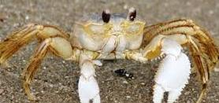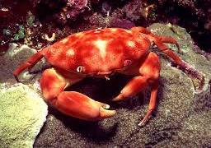
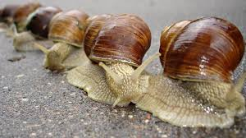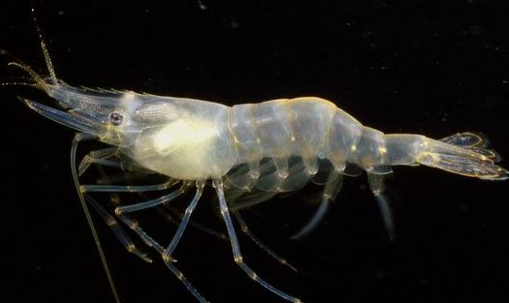
2.Synthesis of chitosan/chitin Ag-ch Nanocomposites
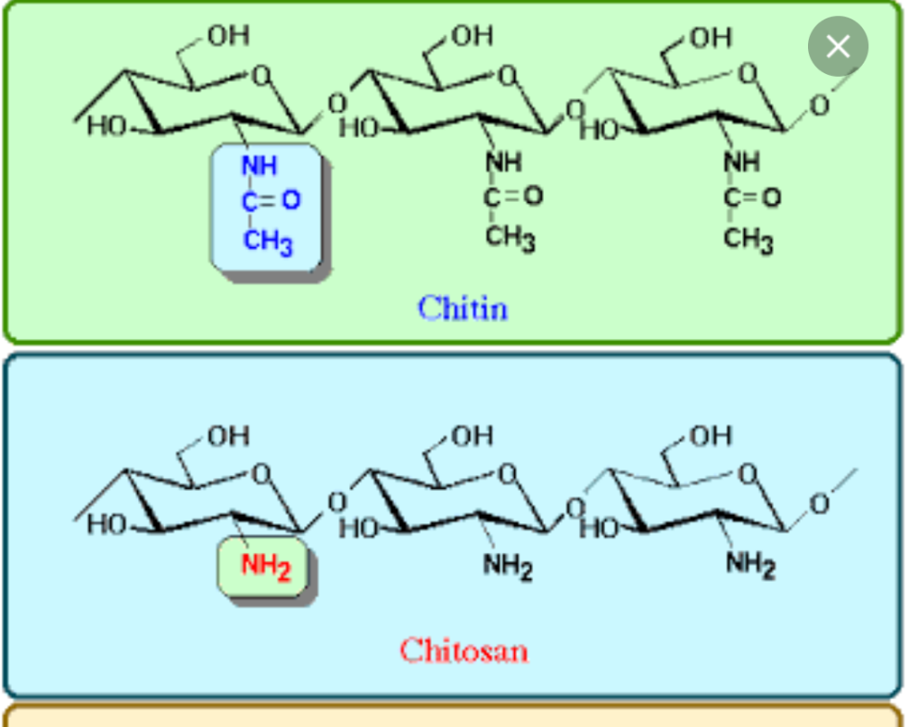

Chitosan/chitin solution (500, 250mg/ml) is mixed with 1ml of 5M NaOH and incubated at room temperature for 10 to 15 min. The chitosan/chitin were stirred vigoursly to pricipitate. Then 1ml of 1mM silver nitrate solution were added and followed by the addition of 0.1% acetic acid (500µl). After continuous stirring the composites were collected. The obtained Ag NP/ch composites was centrifuged at 6000rpm for 10 min, The supernatant were analyzed by using UV –Visible spectrometer to estimated the amount of unreacted AgNPS. The obtained pellet was used for further studies. Centrifuged composites were washed with 1ml of PBS solution followed by centrifugation at 6000 rpm for 10 min. The washing process was repeated twice and the washed chitosan /chitin Ag Nanocomposite is suspended in 250 PBS.
3. Analysis using UV-vis spectrophotometer.
The bionanocomposites were characterized using UV – Visible nanodrop spectrophotometer (ELICO SL 159 UV – VIS Nanodrop spectrophotometer) in the range of 300 to 500nm. The Plasmon peak was observed and noted.
4. Drug loading (Tamoxifen anticancer drug with chitosan /chitin Ag Nanocomposites)
For drug loading added Tamoxifen to chitosan /chitin Ag Nanocomposite in different concentration (0.05g, 0.025g) and incubated overnight at room temperature .The loaded nanoparticles are then centrifuged, and the centrifuge is collected to calculate the amount of unloaded drug by UV-VIS spectroscopy . The loaded nanoparticles are washed with Milliq- water to remove unabsorbed drug.
The amount of drug loaded was calculated as:
Drug loaded (w/w) = Amount of drug - amount of drug unloaded
Weight of nanoparticels

5.Fourier Transmission Infra Red Spectroscopy (FTIR).
FT-IR spectroscopy use to find out the nature of interaction between Tamoxifen, chitin and chitosan Ag nanocomposite, the various physiochemical interactions between tamoxifen, chitin/chitosan Ag nanocomposite and can alter the absorption peaks or broaden the absorption peaks.
6.Efficacy study.
Anti microbial activity by well diffusion method
To determine the antimicrobial of chitin/chitosan Ag NP, nutrient agar medium was sterilized by autoclaving at 121ᴼC for 15 minutes psi pressure and was used. Sterile media was poured aseptically into sterile Petri plat (approximately 20ml) and the plat allowed to solidify at room temperature in sterile condition. After solidification and drying, the plat was seeded with appropriate microorganisms (E.coli) by evenly on to the surface of the medium with a sterile cotton swab and wells (8mm diameter) were cut out from the agar plate using sterile stainless steel pore and filed with 0.1ml of each synthesized chitin/chitosanAg NP in respective wells. Then the plate were incubated at 37ᴼC for 24hours. Then next day, zones of inhibition were measured with measuring scale. The results were read by presence or absence of zone inhibition.
7. Conjugating with Solanum xanthocarpum plant powder.
- Botanical Name : Solanum Xanthocarpum
- Family Name : Solanaceae
- Common Name : Yellow-berried Nightshade
- Part Used : Fruits, Whole Plant
- Habitat : Through out India
- Product offered : Fruits, Whole plant
Uses : Fruits eaten as an anthelmintic and for indigestion. Root is an expectorant, used in Ayurvedic medicine for cough, asthma and chest pain. Also used for flatulence, sore throat, and toothache. Has high concentration of solasodine, a starting material for the manufacture of cortisone and sex hormones. It cures asthma, cough, bronchspasm, sore throat, constipation, an effective expectorant and diuretic. Bhavamisra, an ancient physician mentions it as promoting conception in females. Given with honey, tulsi (Ocimum sanctum), datura (Datura metal), and black pepper it can be effective in cases of bronchial asthma. Stem, flowers and fruits are bitter and carminative and are prescribed for relief in burning sensation in the feet. Leaves are applied locally to relieve pain.
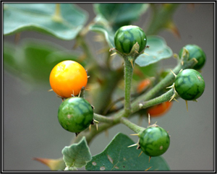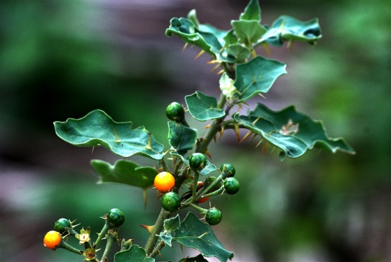
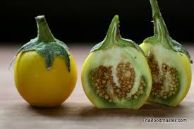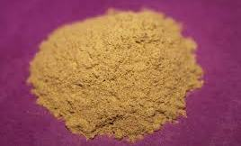
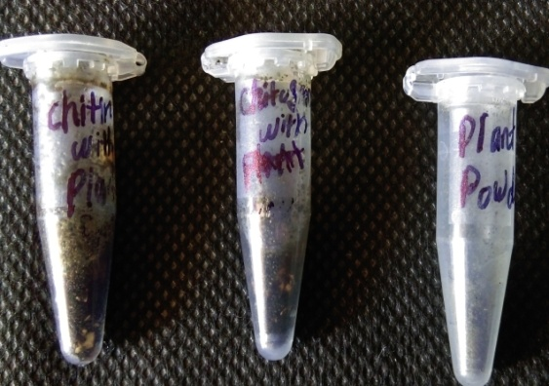

Solanum xanthocarpum was cutting and dried, the dried plant was crushed .Then added the plant powder in different concentration (0.05g,0.025g ) to conjugated with chitin/chitosan Ag nanocomposite .Then treated MCF-7 cell cancer by plant powder to test its as anticancer activity.
8. Anti cancer activity – MTT assay
Sensitivity MCF-7 was determined individually by the MTT colorimetric assay .cells were seeded in flat-bottomed 96-well plate and incubated for 24 h at 37ᴼC and in 5% CO₂. The cells lines were exposed to Tamoxifen loaded chitosan/ chitin sliver Nanocomposite. Chitosan/chitin Sliver Nanocomposite with DMSO solvent as control. Cells were treated with MTT reagent (20µl/well) for 4h at 37ᴼC and then DMSO (100µl) were added for each well to dissolve the formazan crystals. The optical densities (OD) were recorded at 570nm in micro plate reader. Percentage of residual cell viability was determined as (OD of control – OD of treated cells/OD of control) ×100 and percentage of dead cells was determined as (100 – cell viability).
9.DNA damage study.
10. Scaning electron microscopy (SEM).
The morphology of MCF-7 cell cancer was observed before and after treated by Tamoxifen loaded chitin/chtitosan Ag nanocomposite.

Results and discussion
1.Synthesis of chitin /chitosan Ag nanocomposites
Chitin and chitosan bionanocomposites were synthesized using 1ml of 5M NaOH, 1ml of 1mµAgNO3 and 0.1% glacial acidic acid (50µl). .
Tamoxifen is anticancer drug and its loaded with chitin and chitosan bionanocomposiet
Chitosan /AgNp Chitin/Ag NP
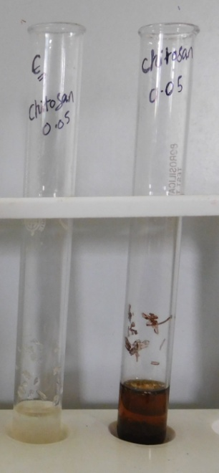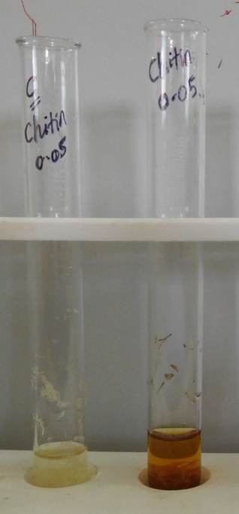

3-Analysis using UV-vis spectrophotometer.
- 0.05g 1mm chitin Ag nanocomposite 380nm
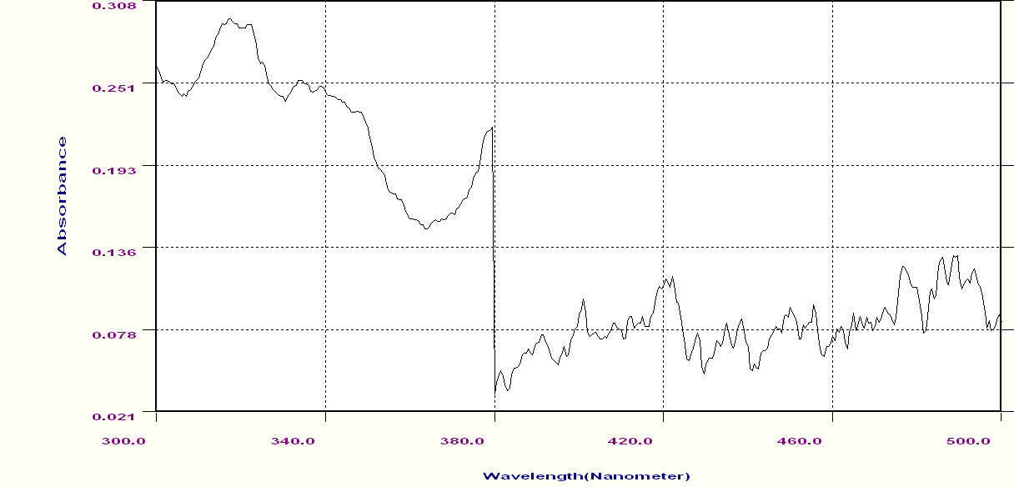

- 0.025g 1mm chitin Ag nanocomposite 370nm
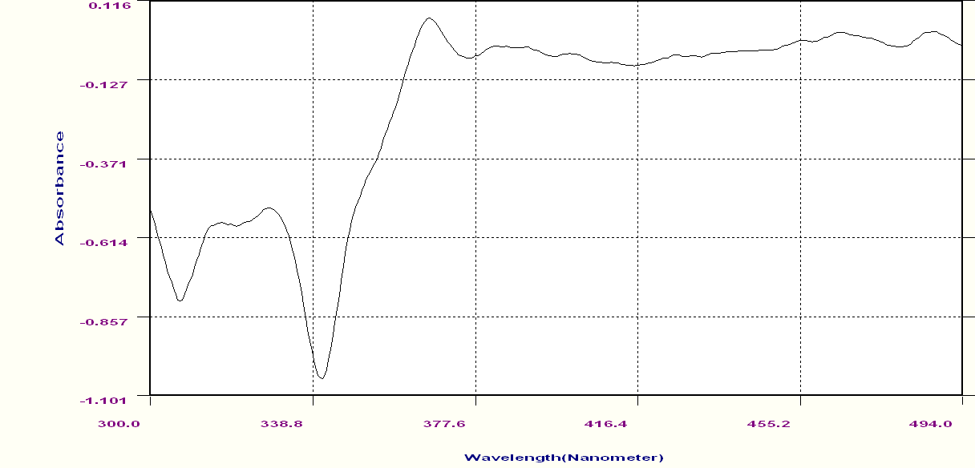

- 0.05g 1mm chitosan Ag nanocomposite 358nm
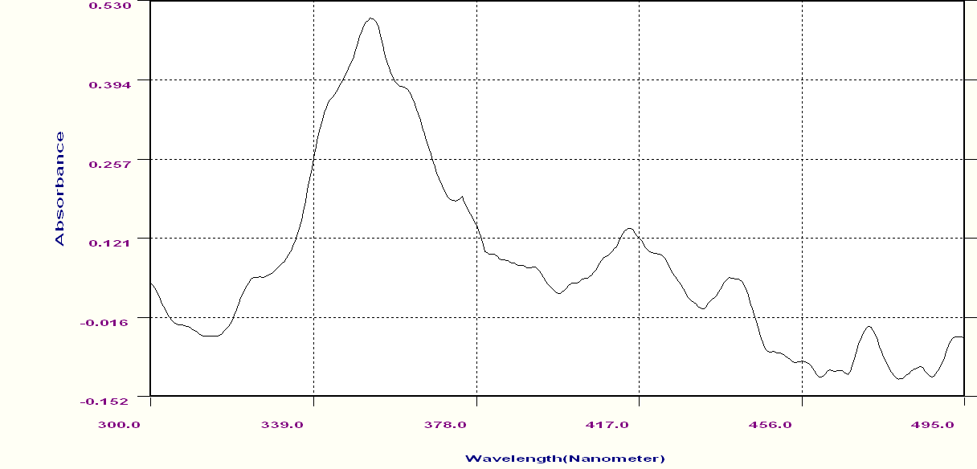

- 0.025g 1mm chitosan Ag nanocomposite 380nm
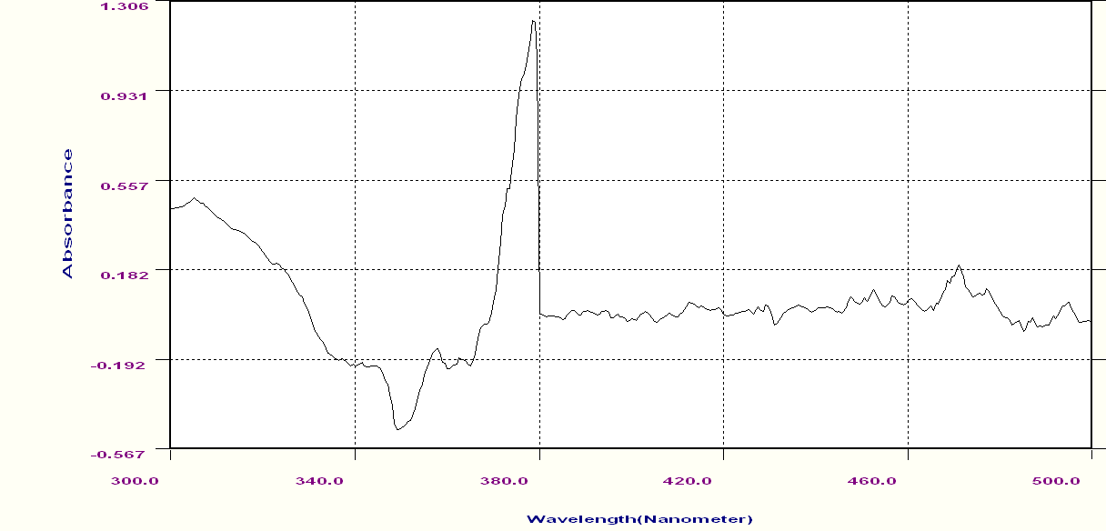

4-Calculation of the amount of drug loaded : UV-VIS
The amount of drug loaded id calculated as:
Drug loaded (w/w) = Amount of drug - amount of drug unloaded
Weight of nanoparticles
Items | Weight of compounds  chitin/chitosan AgNo₃ (g) | Weight of drug (g) | Weight of bionanocomposites (g) | Unloaded drug (w/w) | Loaded drug (w/w) (g)
Chitosan | 0.05 | 0.05 | 0.1 | 0.07 | 0.03
Chitosan | 0.025 | 0.025 | 0.5 | 0.01 | 0.04
Chitin | 0.05 | 0.05 | 0.1 | 0.08 | 0.02
Chitin | 0.025 | 0.025 | 0.5 | 0.03 | 0.02

0.025 1mm chitin Ag nanocomposites (381nm is Plasmon peak)

0.025g 1mm chitosan Ag nanocomposites (379nm)
0.05g 1mm of chitin Ag nanocomposites (372nm)

0.05g 1mm chitosan Ag nanocomposites (412nm)
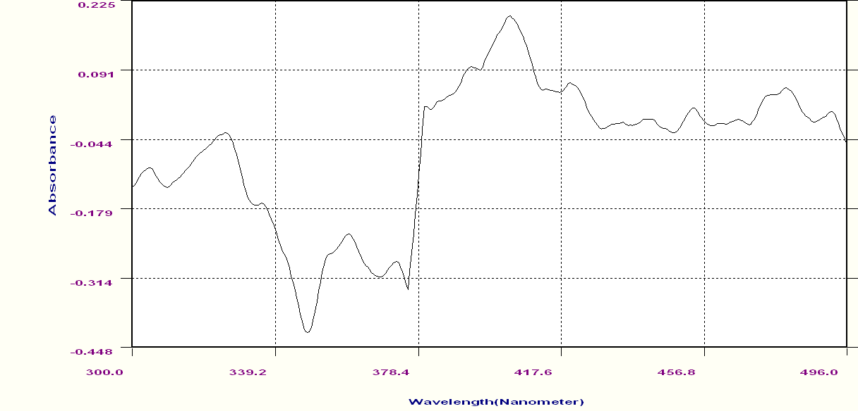

- Anticancer assay –MTT assay.
- The MCF-7 cells in 96-plate were treated with drug loaded chitin/chitosan Ag Nanocompsite.
- MTT dye were added and incubated in \CO2 incubator.
- The dye color was reduced to purple color due to reduction of tetrazolium to formazon crystal.
- The optical density was read at 570nm
- Cell viability was calculated using the formula: (OD of control- OD of test)*100
OD of control
- Cell death was calculated using the formula: (100- cell viability)

Before treatment
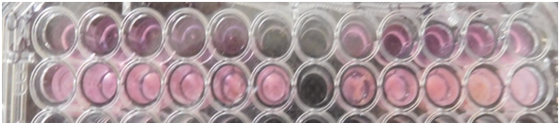
After treatment
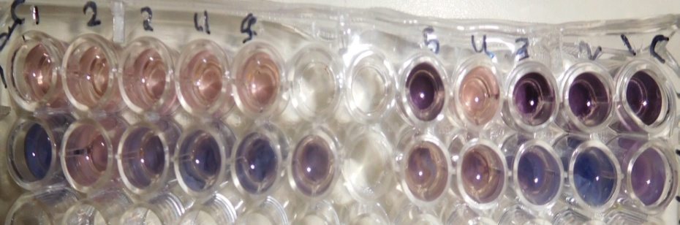
Items | Conc. (g) | OD |  |  | Cell vaiability (%) | Cell death (%)
Items | Conc. (g) | Control | Test |  | Cell vaiability (%) | Cell death (%)
Chitin | 0.05 | 0.093 |  | 0.063 | 32.25% | 67.75
Chitosan | 0.05 | 0.384 |  | 0.329 | 14.32% | 85.68
Chitosan | 0.025 | 0.086 |  | 0.043 | 50% | 50

Cell line
Before treatment
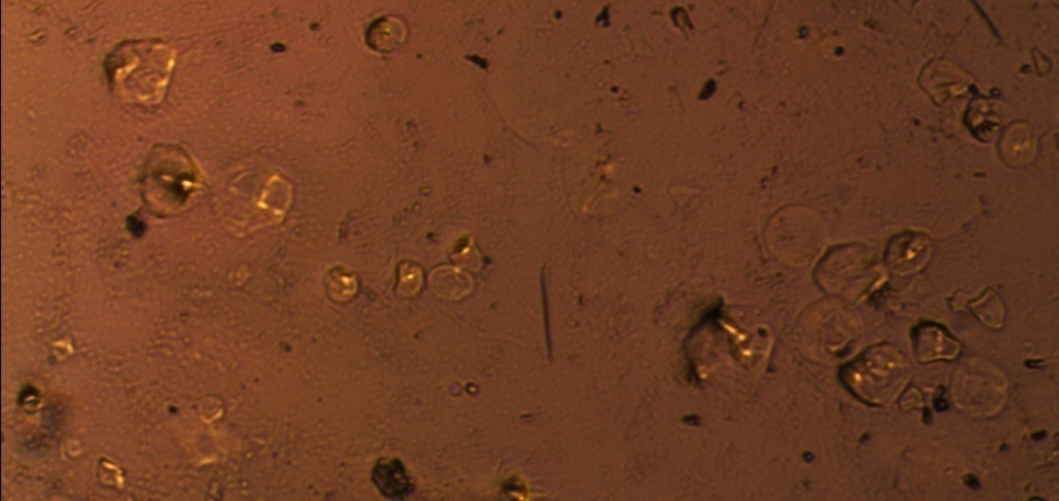
After treatment 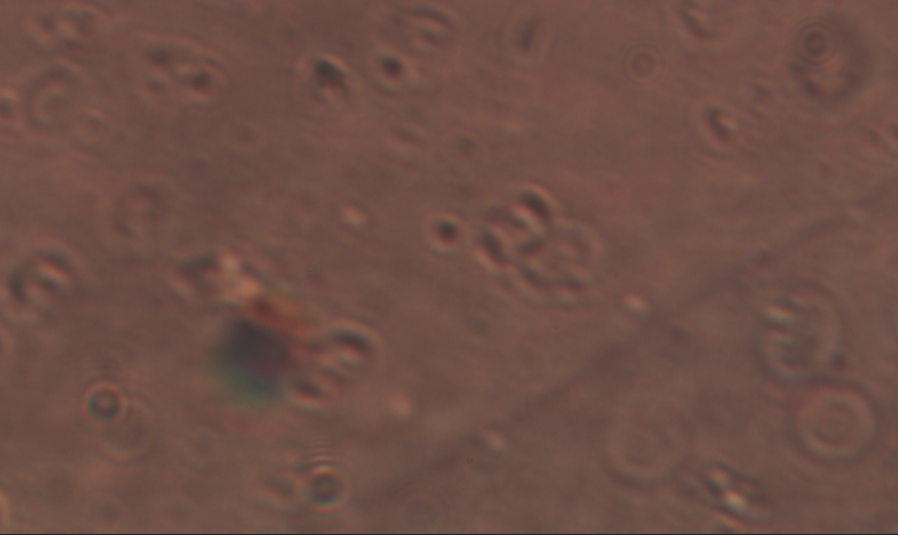

Reference
[1]. Andrade; Vânia Sousa; Barros Neto; Benício de; Fukushima; Kazutaka and Campos-Takaki; Galba Maria,
Revista Iberoamericana de Micología, 2003, 20, 149-153.
[2]. S Komarneni; D Li; B Newalkar,;H Katsuki;A S Bhalla, Langmuir , 2002, 18(15),5959–5962.
[3]. G N Xu; X L Qiao; X L Qiu; J.G.Chen, Colloids and Surfaces A, 2008, 320, 222–226.
[4]. Jayakumar; R.; Menon, D.; Manzoor, K.; Nair,S. V.; Tamura, H.; Biomedical applications of chitin and chitosan based nanomaterials-A
short review; Carbohydrate polymers; 82;2010; 227-232.
[5]. .Pillai, C. K. S.; Paul, W.; Sharma. C. P.; Chitin and Chitosan Polymers: Chemistry, Solubility and Fiber Formation; Progress in PolymerScience; 34; 2009; 641–678.
[6]. Gouda, M.; Keshk, A. S.; Evaluation o f Multifunctional Properties of Cotton Fabric
Based on Metal/Chitosan Film; Carbohydrate Polymers; 80; 2010; 504–512.
[7]. Hu, Z.; Lai, W.; Shan, Y.; Nanocomposite of Chitosan and Silver Oxide and Its Antibacterial Property; Journal of Applied Polymer Science; 108; 2008; 52–56.
[9]. Li, L. H.; Deng, J. C.; Deng, H. R.; Liu, Z. L.;Li , X.; Preparation, characterization and
antimicrobial activities of chitosan/Ag/Zn Oblend films; Chemical Engineering Journal;
160; 2010; 378–382.
[10]. Dastjerdi, R.; Mojtahedi, M. R. M.; Shoshtari,A. M.; Comparing the Effect of Three
Processing Methods for Modification of Filament Yarns with Inorganic Nanocomposite Filler and Their Bioactivity Against Staphylococcus aurous; Macromolecular Research; 17; 2009; 378–387.
[11] . Castanon, G. A.; Nino-Martinez, N.; Gutierrez ,F.; Mendoza, J. R.; Ruiz, F.; Synthesis and antimicrobial activity of silver nanoparticles with different sizes; J Nanopart Res.; 10;
2008; 1343-1348.
[12]. L. Illum, “Chitosan and its use as a pharmaceutical excipient”, Pharm. Res., vol. 15, pp.1326– 1331, September 1998.
[13]. V. Dodane, V.D. Vilivalam, “Pharmaceutical applications of Chitosan”, Pharm. Sci. Technol. Today, vol. 1, pp. 246–253, September 1998.
[14]. O. Felt, P. Buri, R. Gurny, “Chitosan: a unique polysaccharide for drug delivery”, Drug Dev. Ind. Pharm., vol. 24, pp. 979–993, November 1998.
[15]. W. Tiyaboonchai, Chitosan nanoparticles: a promising system for drug delivery, Naresuan Univ. J., vol. 11, no. 3, pp.51-66, September 2003.
[16]. D.B. Shenoy, M.M. Amiji, “Poly(ethylene oxide)-modified poly(epsilon-caprolactone) nanoparticles for targeted delivery of tamoxifen in breast cancer”, Int. J. Pharm., vol. 293, pp.261–270, February 2005.
[17]. Badawy, M.E.I. and E.I. Rabea, A biopolymer chitosan and its derivatives as promising antimicrobial agents against plant pathogens and their applications in crop protection.
[18]. International Journal of Carbohydrate
[19]. Sang-Hoon Lim ,Samuel M.Hudson, Journal of Macromolecular Science,Part C-PolymerReviews,2003,43,233.
[20]. Peter M.G.,Domard A.,Muzzarelli R.A.A., Advances in Chitin Science Vol.IV, Universitat Potsdam:Potsdam,Germany,2000.
[21] .Yu L, Dean K, Li L: Polymer blends and composites from renewable
resources. Prog Polym Sci 2006, 31:576–602.
[22]. Sahoo D, Sahoo S, Mohanty P, S, Nayak PL, Chitosan: a new versatile biopolymer for various application, Designed Monomers, 12, 377-404, 2009
[23]. Mikos A.G., Lyman M.D., Freed L.E., & Langer R., Weatting of poly (L_lactic acid )and poly (DL-lactic-co-glycolic acid )foams for tissue culture, Biomaterials, 15(1),55-8,1994.
[24]. Kas H.S., Chitosan: properties, preparation and application to microparticulate system, journal of microencapsulation, 14(6),689-711,1997 .
[25]. A.S. Pedro, E. Cabral-Albuquerque, D. Ferreira, B. Sarmento, Carbohydr. Polym.
76 (2009) 508.
[26]. J.F. Almeida, A. Fonseca, C. Baptista, E. Leite, M.H. Gil, J. Mater. Sci.: Mater. Med. (2007) 2317.
[27]. R.D. Joerger, S. Sabesan, D. Visioli, D. Urian, M.C. Joerger, Packag. Technol. Sci.
22 (2009) 138.
[28]. A.M. Fayaz, K. Balaji, P.T. Kalaichelvan, R. Venkatesan, Colloids Surf. B: Biointerfaces
74 (2009) 123.
[29] . A. Subramanian, A.V. Rau, H. Kaligotla, Carbohydr. Polym. 66 (2006) 332.
[30] . Y. Sun, A.J. Wan, J. Appl. Polym. Sci. 105 (2007) 561.

