Scientific Poster template for PowerPoint. (Title: 72 pt, regular)
Poster category (i.e. ’The importance of basic sciences for
Name and surname of the authors (28 pt regular)
Development’)

This is an example of a poster. Please use the template, but feel free to adjust areas, image and image size, etc. Please include all information in the header and footer. Your poster will be presented electronically.

The conclusion first (headlines: 44 pt bold)
The purpose of a poster is to reach out with your message! Capture the reader's interest by starting with the most important thing.

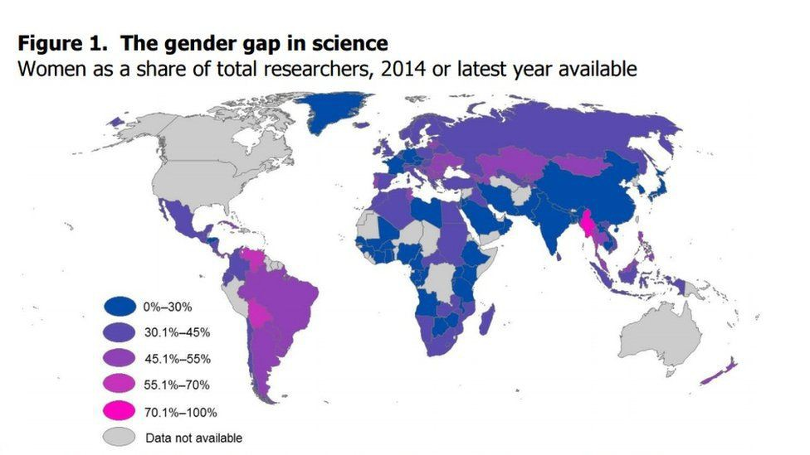
Use images! A picture is worth 1000 words. (Image caption text: 28 pt regular)
Use charts to illustrate results. Graphs and charts used should be highly relevant and the axes well labelled.

Some tips:
- Sans-serif font is easier to read. Left aligned text or justified text are also more easily read. Shorter paragraphs are recommended.
- If you're inexperienced with poster layouts, get help from a mentor or colleague, or take a look online at some layouts that appeal to you.
Videos can be included in the poster. In order to embed movies inside PDF please use Adobe Acrobat Pro followingthe instructions here. Only mp4 files are accepted encoded with h264 codec.
Present what has been done, by whom and the results and conclusions. Keep it short and sweet, and make sure you use language that can be understood by people also outside your field of research. (Body text: 34 pt regular)

What to include
Your poster should highlight the objectives, methodology and main findings of the research. You want to address:
- What is the main focus of your research?
- Why is this research important? What's the context? Why are you motivated to do it?
- How - what methodology did you use? Are your results therefore reliable and repeatable?
- Results & IMPACT - how has your research been received? What is it used for? How does it work in the community?
Use images
The poster should act as an ad, not a report. Do not try to bring in everything! Many posters are too text heavy. You want to attract attention and make people curious. Illustrative images allow you to remove unnecessary text and capture interest. The higher quality images the better.
Always write explanatory captions. 28pt regular (the image above shows a collaboration between women scientists).
Finish by giving an idea of the next steps for your research or project, or how/why it will be relevant to global science.

Name Surname (25 pt bold) Institute or affiliation

Consider adding a photo of yourself.
Logo of relevant affiliation (i.e.
Your institute, organization or OWSD National Chapter)
Title • Department City, Country
Email: name@domain.com

